UNITED STATES
SECURITIES AND EXCHANGE COMMISSION
WASHINGTON, D.C. 20549

FORM 10-Q

☒ QUARTERLY REPORT PURSUANT TO SECTION 13 OR 15(d) OF THE SECURITIES EXCHANGE ACT OF 1934

For the quarterly period ended June 30, 2026

☐ TRANSITION REPORT PURSUANT TO SECTION 13 OR 15(d) OF THE SECURITIES EXCHANGE ACT OF 1934

For the transition period from ___________ to ___________

GENELUX CORPORATION
(Exact name of registrant as specified in its charter)

Delaware |  | 001-41599 |  | 77-0583529
(State or other jurisdiction of  incorporation or organization) |  | Commission  File Number |  | (IRS Employer  Identification No.)

2625 Townsgate Road, Suite 230, Westlake Village, California 91361
(Address of Principal Executive Offices)

(805) 267-9889
(Registrant’s telephone number, including area code)

(Former name, former address and former fiscal year, if changed since last report)

Securities registered pursuant to Section 12(b) of the Exchange Act:

Title of each class registered: |  | Trading symbol: |  | Name of each exchange on which registered:
Common Stock, par value $0.001 per share |  | GNLX |  | The Nasdaq Stock Market LLC  (Nasdaq Capital Market)

Securities registered under Section 12(g) of the Exchange Act: None

Indicate by check mark whether the issuer (1) filed all reports required to be filed by Section 13 or 15(d) of the Securities Exchange Act of 1934 during the preceding 12 months (or for such shorter period that the registrant was required to file such reports), and (2) has been subject to such filing requirements for the past 90 days. Yes ☒ No ☐

Indicate by check mark whether the registrant has submitted electronically and posted on its corporate website, if any, every Interactive Data File required to be submitted and posted pursuant to Rule 405 of Regulation S-T (§232.405 of this chapter) during the preceding 12 months (or for such shorter period that the registrant was required to submit and post such files). Yes ☒ No ☐

Indicate by check mark whether the registrant is a large accelerated filer, an accelerated filer, a non-accelerated filer or smaller reporting company filer. See definition of “accelerated filer” and “large accelerated filer” in Rule 12b-2 of the Exchange Act (Check one):

Large accelerated filer ☐ | Accelerated filer ☐
Non-accelerated filer ☒ | Smaller reporting company ☒
 | Emerging growth company ☒

If an emerging growth company, indicate by check mark if the registrant has elected not to use the extended transition period for complying with any new or revised financial accounting standards provided pursuant to Section 13(a) of the Exchange Act. ☒

Indicate by check mark whether the registrant is a shell company as defined in Rule 12b-2 of the Exchange Act. Yes ☐ No ☒

The number of shares issued and outstanding of each of the issuer’s classes of common equity as of August 11, 2026 was 45,245,335.

Special Note Regarding Forward-Looking Statements

This Quarterly Report on Form 10-Q (“Quarterly Report”) contains forward-looking statements within the meaning of the federal securities laws made pursuant to the safe harbor provisions of the Private Securities Litigation Reform Act of 1995. All statements, other than statements of historical facts contained in this Quarterly Report, are forward-looking statements. These statements involve known and unknown risks, uncertainties and other important factors that may cause our actual results, performance or achievements to be materially different from any future results, performance or achievements expressed or implied by the forward-looking statements.

Forward-looking statements contained in this Quarterly Report include statements regarding:

 | ● | the timing, progress and results of clinical studies for our product candidates, including the development of our only clinical-stage product candidate, Olvi-Vec;
 | ● | the timing, scope and likelihood of regulatory filings and approvals, including final regulatory approval of our product candidates;
 | ● | the potential benefits and market opportunity for our product candidates and CHOICE platform;
 | ● | expectations regarding the size, scope and design of clinical studies;
 | ● | our manufacturing, commercialization, and marketing plans and strategies;
 | ● | our plans to hire additional personnel and our ability to attract and retain such personnel;
 | ● | our estimates of the number of patients who suffer from the diseases we are targeting and potential growth in our target markets;
 | ● | our expectations regarding the approval and use of our product candidates;
 | ● | our competitive position and the development and impact of competing therapies that are or may become available;
 | ● | expectations regarding future events under collaboration and licensing agreements, including potential future payments, as well as our plans and strategies for entering into further collaboration and licensing agreements;
 | ● | our intellectual property position, including the scope of protection we are able to establish and maintain for intellectual property rights covering product candidates we may develop, including the extensions of existing patent terms where available, the validity of intellectual property rights held by third parties, and our ability not to infringe, misappropriate or otherwise violate any third-party intellectual property rights;
 | ● | the rate and degree of market acceptance and clinical utility of product candidates we may develop;
 | ● | our estimates regarding expenses, future revenue, capital requirements and needs for additional financing;
 | ● | our future financial performance;
 | ● | the period over which we estimate our existing cash, cash equivalents, restricted cash and marketable securities will be sufficient to fund our future operations;
 | ● | our expected use of net proceeds from our financing transactions;
 | ● | the impact of laws and regulations;
 | ● | the impact of geopolitical and macroeconomic factors; and
 | ● | other risks and uncertainties, including those described under Part II, Item 1A, “Risk Factors” in this Quarterly Report.

In some cases, you can identify forward-looking statements by terms such as “may,” “will,” “should,” “expect,” “plan,” “anticipate,” “could,” “intend,” “target,” “project,” “contemplates,” “believes,” “estimates,” “predicts,” “potential” or “continue” or the negative of these terms or other similar expressions. The forward-looking statements in this Quarterly Report are only predictions. We have based these forward-looking statements largely on our current expectations and projections about future events and financial trends that we believe may affect our business, financial condition and results of operations. These forward-looking statements speak only as of the date of this Quarterly Report and are subject to a number of risks, uncertainties and assumptions described under the sections titled “Risk Factors” and “Management’s Discussion and Analysis of Financial Condition and Results of Operations” and elsewhere in our Annual Report on Form 10-K, as amended, for the year ended December 31, 2025 (the “Annual Report”) and in this Quarterly Report. Because forward-looking statements are inherently subject to risks and uncertainties, some of which cannot be predicted or quantified and some of which are beyond our control, you should not rely on these forward-looking statements as predictions of future events. The events and circumstances reflected in our forward-looking statements may not be achieved or occur and actual results could differ materially from those projected in the forward-looking statements. Moreover, we operate in an evolving environment. New risk factors and uncertainties may emerge from time to time, and it is not possible for management to predict all risk factors and uncertainties. Except as required by applicable law, we undertake no obligation to publicly update or revise any forward-looking statements contained herein, whether as a result of any new information, future events, changed circumstances or otherwise. You should, however, review the factors and risks we describe in the reports we will file from time to time with the U.S. Securities and Exchange Commission (the “SEC”) after the date of this Quarterly Report.

In addition, statements that “we believe” and similar statements reflect our beliefs and opinions on the relevant subject. These statements are based on information available to us as of the date of this Quarterly Report, and while we believe such information provides a reasonable basis for these statements, such information may be limited or incomplete. Our statements should not be read to indicate that we have conducted an exhaustive inquiry into, or review of, all potentially available relevant information. These statements are inherently uncertain, and you are cautioned not to unduly rely on these statements.

GENELUX CORPORATION
FORM 10-Q
JUNE 30, 2026
TABLE OF CONTENTS

PART I— FINANCIAL INFORMATION |  | 3
Item 1. | Condensed Financial Statements | 3
 | Condensed Balance Sheets | 3
 | Condensed Statements of Operations and Comprehensive Loss | 4
 | Condensed Statements of Stockholders’ Equity | 5
 | Condensed Statements of Cash Flows | 6
 | Notes to Condensed Financial Statements | 7
Item 2. | Management’s Discussion and Analysis of Financial Condition and Results of Operations | 19
Item 3. | Quantitative and Qualitative Disclosures About Market Risk | 28
Item 4. | Controls and Procedures | 29
PART II— OTHER INFORMATION |  | 30
Item 1. | Legal Proceedings | 30
Item 1A. | Risk Factors | 30
Item 2. | Unregistered Sales of Equity Securities and Use of Proceeds | 31
Item 3. | Defaults Upon Senior Securities | 31
Item 4. | Mine Safety Disclosures | 31
Item 5. | Other Information | 31
Item 6. | Exhibits | 32
SIGNATURES |  | 33

2

PART I—FINANCIAL INFORMATION

Item 1. Condensed Financial Statements

Genelux Corporation
Condensed Balance Sheets
(in thousands, except per share amounts)

 |  | June 30,  2026 |  |  |  | December 31,  2025
 |  |  | (unaudited)
ASSETS
Current assets:
Cash, cash equivalents and restricted cash |  | $ | 9,184 |  |  | $ | 5,333
Marketable securities |  |  | 9,486 |  |  |  | 9,262
Prepaid expenses and other current assets |  |  | 474 |  |  |  | 535
Total current assets |  |  | 19,144 |  |  |  | 15,130
Property and equipment, net |  |  | 4,603 |  |  |  | 2,170
Right of use assets |  |  | 2,312 |  |  |  | 1,583
Other assets |  |  | 146 |  |  |  | 144
Total Assets |  | $ | 26,205 |  |  | $ | 19,027
LIABILITIES AND STOCKHOLDERS’ EQUITY
Current liabilities:
Accounts payable and accrued expenses |  | $ | 6,918 |  |  | $ | 4,358
Accrued payroll and payroll taxes |  |  | 754 |  |  |  | 1,440
Lease liabilities, current portion |  |  | 326 |  |  |  | 427
Total current liabilities |  |  | 7,998 |  |  |  | 6,225
Lease liabilities, long-term portion |  |  | 2,094 |  |  |  | 1,258
Total liabilities |  |  | 10,092 |  |  |  | 7,483
Commitments and contingencies (Note 8) |  |  | - |  |  |  | -
Stockholders’ equity:
Common stock, par value $0.001, 200,000,000 shares authorized; 45,103,461 and 38,139,144 shares issued and outstanding, respectively |  |  | 45 |  |  |  | 38
Treasury stock, 433,333 shares, at cost |  |  | (433 | ) |  |  | (433 | )
Additional paid-in capital |  |  | 318,440 |  |  |  | 295,468
Accumulated other comprehensive (loss) income |  |  | (2 | ) |  |  | 9
Accumulated deficit |  |  | (301,937 | ) |  |  | (283,538 | )
Total stockholders’ equity |  |  | 16,113 |  |  |  | 11,544
Total Liabilities and Stockholders’ Equity |  | $ | 26,205 |  |  | $ | 19,027

The accompanying notes are an integral part of these condensed financial statements.

3

Genelux Corporation
Condensed Statements of Operations and Comprehensive Loss
(in thousands, except share amounts)
(unaudited)

 |  | 2026 |  |  |  | 2025 |  |  |  | 2026 |  |  |  | 2025
 |  | Three Months Ended |  |  |  |  |  |  |  | Six Months Ended
 |  | June 30, |  |  |  |  |  |  |  | June 30,
 |  | 2026 |  |  |  | 2025 |  |  |  | 2026 |  |  |  | 2025
Revenue |  | $ | - |  |  | $ | - |  |  | $ | - |  |  | $ | -
Operating expenses:
Research and development |  |  | 6,508 |  |  |  | 4,758 |  |  |  | 12,286 |  |  |  | 9,456
General and administrative |  |  | 3,137 |  |  |  | 3,034 |  |  |  | 6,530 |  |  |  | 6,152
Total operating expenses |  |  | 9,645 |  |  |  | 7,792 |  |  |  | 18,816 |  |  |  | 15,608
Operating loss |  |  | (9,645 | ) |  |  | (7,792 | ) |  |  | (18,816 | ) |  |  | (15,608 | )
Other income:
Interest income |  |  | 127 |  |  |  | 224 |  |  |  | 300 |  |  |  | 408
Bond accretion income |  |  | 47 |  |  |  | 112 |  |  |  | 117 |  |  |  | 252
Total other income |  |  | 174 |  |  |  | 336 |  |  |  | 417 |  |  |  | 660
Net loss |  | $ | (9,471 | ) |  | $ | (7,456 | ) |  | $ | (18,399 | ) |  | $ | (14,948 | )
Net loss per share - basic and diluted |  | $ | (0.21 | ) |  | $ | (0.20 | ) |  | $ | (0.41 | ) |  | $ | (0.41 | )
Weighted-average shares outstanding - basic and diluted |  |  | 44,959,426 |  |  |  | 37,946,330 |  |  |  | 44,557,426 |  |  |  | 36,346,125
Other comprehensive loss:
Net unrealized gain (loss) on marketable securities |  |  | 3 |  |  |  | (26 | ) |  |  | (11 | ) |  |  | (61 | )
Comprehensive loss |  | $ | (9,468 | ) |  | $ | (7,482 | ) |  | $ | (18,410 | ) |  | $ | (15,009 | )

The accompanying notes are an integral part of these condensed financial statements.

4

Genelux Corporation
Condensed Statements of Stockholders’ Equity
(in thousands, except share amounts)
(unaudited)

 |  | Shares |  |  |  | Amount |  |  |  | Shares |  |  |  | Amount |  |  |  | Capital |  |  |  | Income (Loss) |  |  |  | Deficit |  |  |  | Total
 |  | Common Stock |  |  |  |  |  |  |  | Treasury Stock |  |  |  |  |  |  |  | Additional  Paid-in |  |  |  | Accumulated  Other Comprehensive |  |  |  | Accumulated
 |  | Shares |  |  |  | Amount |  |  |  | Shares |  |  |  | Amount |  |  |  | Capital |  |  |  | Income (Loss) |  |  |  | Deficit |  |  |  | Total
Balance, December 31, 2025 |  |  | 38,139,144 |  |  | $ | 38 |  |  |  | (433,333 | ) |  | $ | (433 | ) |  | $ | 295,468 |  |  | $ | 9 |  |  | $ | (283,538 | ) |  | $ | 11,544
Fair value of vested options |  |  | - |  |  |  | - |  |  |  | - |  |  |  | - |  |  |  | 1,394 |  |  |  | - |  |  |  | - |  |  |  | 1,394
Unrealized loss on marketable securities |  |  | - |  |  |  | - |  |  |  | - |  |  |  | - |  |  |  | - |  |  |  | (14 | ) |  |  | - |  |  |  | (14 | )
Fair value of vested restricted stock units |  |  | 29,063 |  |  |  | - |  |  |  | - |  |  |  | - |  |  |  | 319 |  |  |  | - |  |  |  | - |  |  |  | 319
Cost of stock option modifications and repricing |  |  | - |  |  |  | - |  |  |  | - |  |  |  | - |  |  |  | 68 |  |  |  | - |  |  |  | - |  |  |  | 68
Issuance of common stock for cash |  |  | 6,666,667 |  |  |  | 7 |  |  |  | - |  |  |  | - |  |  |  | 18,518 |  |  |  | - |  |  |  | - |  |  |  | 18,525
Issuance of common stock upon exercise of stock options |  |  | 5,542 |  |  |  | - |  |  |  | - |  |  |  | - |  |  |  | 13 |  |  |  | - |  |  |  | - |  |  |  | 13
Net loss during the three months ended March 31, 2026 |  |  | - |  |  |  | - |  |  |  | - |  |  |  | - |  |  |  | - |  |  |  | - |  |  |  | (8,928 | ) |  |  | (8,928 | )
Balance, March 31, 2026 |  |  | 44,840,416 |  |  | $ | 45 |  |  |  | (433,333 | ) |  | $ | (433 | ) |  | $ | 315,780 |  |  | $ | (5 | ) |  | $ | (292,466 | ) |  | $ | 22,921
Fair value of vested options |  |  | - |  |  |  | - |  |  |  | - |  |  |  | - |  |  |  | 1,417 |  |  |  | - |  |  |  | - |  |  |  | 1,417
Unrealized gain on marketable securities |  |  | - |  |  |  | - |  |  |  | - |  |  |  | - |  |  |  | - |  |  |  | 3 |  |  |  | - |  |  |  | 3
Fair value of vested restricted stock units |  |  | 123,965 |  |  |  | - |  |  |  | - |  |  |  | - |  |  |  | 782 |  |  |  | - |  |  |  | - |  |  |  | 782
Cost of stock option modifications and repricing |  |  | - |  |  |  | - |  |  |  | - |  |  |  | - |  |  |  | 68 |  |  |  | - |  |  |  | - |  |  |  | 68
Issuance of common stock for cash |  |  | 120,087 |  |  |  | - |  |  |  | - |  |  |  | - |  |  |  | 339 |  |  |  | - |  |  |  | - |  |  |  | 339
Common stock issued under equity award plans |  |  | 18,993 |  |  |  | - |  |  |  | - |  |  |  | - |  |  |  | 54 |  |  |  | - |  |  |  | - |  |  |  | 54
Net loss during the three months ended June 30, 2026 |  |  | - |  |  |  | - |  |  |  | - |  |  |  | - |  |  |  | - |  |  |  | - |  |  |  | (9,471 | ) |  |  | (9,471 | )
Balance, June 30, 2026 |  |  | 45,103,461 |  |  | $ | 45 |  |  |  | (433,333 | ) |  | $ | (433 | ) |  | $ | 318,440 |  |  | $ | (2 | ) |  | $ | (301,937 | ) |  | $ | 16,113

 |  |  |  |  |  |  |  |  |  |  |  |  |  |  |  |  |  | Additional |  |  |  | Accumulated Other
 |  | Common Stock |  |  |  |  |  |  |  | Treasury Stock |  |  |  |  |  |  |  | Paid-in |  |  |  | Comprehensive |  |  |  | Accumulated
 |  | Shares |  |  |  | Amount |  |  |  | Shares |  |  |  | Amount |  |  |  | Capital |  |  |  | Income (Loss) |  |  |  | Deficit |  |  |  | Total
Balance, December 31, 2024 |  |  | 34,728,140 |  |  | $ | 35 |  |  |  | (433,333 | ) |  | $ | (433 | ) |  | $ | 278,001 |  |  | $ | 64 |  |  | $ | (251,393 | ) |  |  | 26,274
Fair value of vested options |  |  | - |  |  |  | - |  |  |  | - |  |  |  | - |  |  |  | 1,423 |  |  |  | - |  |  |  | - |  |  |  | 1,423
Unrealized loss on marketable securities |  |  | - |  |  |  | - |  |  |  | - |  |  |  | - |  |  |  | - |  |  |  | (35 | ) |  |  | - |  |  |  | (35 | )
Fair value of vested restricted stock units |  |  | - |  |  |  | - |  |  |  | - |  |  |  | - |  |  |  | 103 |  |  |  | - |  |  |  | - |  |  |  | 103
Cost of stock option repricing |  |  | - |  |  |  | - |  |  |  | - |  |  |  | - |  |  |  | 6 |  |  |  | - |  |  |  | - |  |  |  | 6
Issuance of common stock for cash |  |  | 3,000,000 |  |  |  | 3 |  |  |  | - |  |  |  | - |  |  |  | 9,550 |  |  |  | - |  |  |  | - |  |  |  | 9,553
Issuance of common stock upon exercise of stock options |  |  | 5,000 |  |  |  | - |  |  |  | - |  |  |  | - |  |  |  | 14 |  |  |  | - |  |  |  | - |  |  |  | 14
Net loss during the three months ended March 31, 2025 |  |  | - |  |  |  | - |  |  |  | - |  |  |  | - |  |  |  | - |  |  |  | - |  |  |  | (7,492 | ) |  |  | (7,492 | )
Balance, March 31, 2025 |  |  | 37,733,140 |  |  | $ | 38 |  |  |  | (433,333 | ) |  | $ | (433 | ) |  | $ | 289,097 |  |  | $ | 29 |  |  | $ | (258,885 | ) |  | $ | 29,846
Fair value of vested options |  |  | - |  |  |  | - |  |  |  | - |  |  |  | - |  |  |  | 1,290 |  |  |  | - |  |  |  | - |  |  |  | 1,290
Unrealized loss on marketable securities |  |  | - |  |  |  | - |  |  |  | - |  |  |  | - |  |  |  | - |  |  |  | (26 | ) |  |  | - |  |  |  | (26 | )
Fair value of vested restricted stock units |  |  | - |  |  |  | - |  |  |  | - |  |  |  | - |  |  |  | 185 |  |  |  | - |  |  |  | - |  |  |  | 185
Cost of stock option modifications and repricing |  |  | - |  |  |  | - |  |  |  | - |  |  |  | - |  |  |  | 7 |  |  |  | - |  |  |  | - |  |  |  | 7
Common stock issued under equity award plans |  |  | 25,876 |  |  |  | - |  |  |  | - |  |  |  | - |  |  |  | 52 |  |  |  | - |  |  |  | - |  |  |  | 52
Net loss during the three months ended June 30, 2025 |  |  | - |  |  |  | - |  |  |  | - |  |  |  | - |  |  |  | - |  |  |  | - |  |  |  | (7,456 | ) |  |  | (7,456 | )
Net loss |  |  | - |  |  |  | - |  |  |  | - |  |  |  | - |  |  |  | - |  |  |  | - |  |  |  | (7,456 | ) |  |  | (7,456 | )
Balance, June 30, 2025 |  |  | 37,759,016 |  |  | $ | 38 |  |  |  | (433,333 | ) |  | $ | (433 | ) |  | $ | 290,631 |  |  | $ | 3 |  |  | $ | (266,341 | ) |  | $ | 23,898

The accompanying notes are an integral part of these condensed financial statements.

5

Genelux Corporation
Condensed Statements of Cash Flows
(in thousands)
(unaudited)

 |  | 2026 |  |  |  | 2025
 |  | Six Months Ended June 30,
 |  | 2026 |  |  |  | 2025
Cash Flows from operating activities
Net loss |  | $ | (18,399 | ) |  | $ | (14,948 | )
Adjustments to reconcile net loss to net cash used in operating activities:
Depreciation expense |  |  | 20 |  |  |  | 122
Accretion of discounts on marketable securities |  |  | (117 | ) |  |  | (157 | )
Right-of-use asset |  |  | 170 |  |  |  | 160
Fair value of vested options |  |  | 2,818 |  |  |  | 2,713
Fair value of restricted stock units |  |  | 1,101 |  |  |  | 288
Cost of stock option modifications and repricing |  |  | 136 |  |  |  | 13
Changes in operating assets and liabilities:
Prepaid expenses and other assets |  |  | 57 |  |  |  | (590 | )
Accounts payable and accrued expenses |  |  | 2,562 |  |  |  | 453
Accrued payroll and payroll taxes |  |  | (688 | ) |  |  | (387 | )
Lease liability |  |  | (163 | ) |  |  | (161 | )
Net cash used in operating activities |  |  | (12,503 | ) |  |  | (12,494 | )
Cash Flows from investing activities
Purchases of property and equipment |  |  | (2,453 | ) |  |  | (145 | )
Purchases of marketable securities |  |  | (14,398 | ) |  |  | (12,999 | )
Proceeds from maturities of marketable securities |  |  | 14,280 |  |  |  | 14,000
Net cash (used in) provided by investing activities |  |  | (2,571 | ) |  |  | 856
Cash Flows from financing activities
Proceeds from common stock issued for Company equity award programs |  |  | 47 |  |  |  | 52
Proceeds from the exercise of stock options |  |  | 13 |  |  |  | 14
Proceeds from common stock issued |  |  | 18,865 |  |  |  | 9,553
Net cash provided by financing activities |  |  | 18,925 |  |  |  | 9,619
Net increase (decrease) in cash, cash equivalents and restricted cash |  |  | 3,851 |  |  |  | (2,019 | )
Cash, cash equivalents and restricted cash
BEGINNING OF PERIOD |  |  | 5,333 |  |  |  | 8,565
END OF PERIOD |  | $ | 9,184 |  |  | $ | 6,546
Supplemental non-cash financing disclosures:
Unrealized loss on marketable securities |  | $ | (11 | ) |  | $ | (61 | )
Remeasurement of right of use asset and lease liability upon lease extension |  | $ | 896 |  |  | $ | -

The accompanying notes are an integral part of these condensed financial statements.

6

Genelux Corporation
Notes to Condensed Financial Statements
(unaudited)
(in thousands, except share amounts and per share data)

NOTE 1 – BASIS OF PRESENTATION

Organization and Operations

Genelux Corporation (Genelux or the Company), a Delaware corporation, incorporated on September 4, 2001, is a late clinical-stage biopharmaceutical company located in Westlake Village, California. The Company is engaged in the research and development of diagnostic and therapeutic solutions for cancer for which there is no effective treatment today. The Company is focused on developing a pipeline of next-generation oncolytic immunotherapies for patients suffering from aggressive and/or difficult-to-treat tumor types.

Liquidity and Capital Resources

The accompanying condensed financial statements have been prepared on a going concern basis, which contemplates the realization of assets and the settlement of liabilities and commitments in the normal course of business. The Company has experienced recurring losses from operations since inception and incurred a net loss of $18.4 million and cash used in operations of $12.5 million during the six months ended June 30, 2026. These factors raise substantial doubt about the Company’s ability to continue as a going concern. In addition, the Company’s independent registered public accounting firm has included an explanatory paragraph in its report on the Company’s December 31, 2025 financial statements with respect to substantial doubt about the Company’s ability to continue as a going concern. The ability of the Company to continue as a going concern is dependent upon the Company’s ability to raise additional funds and implement its strategies. The financial statements do not include any adjustments that might be necessary if the Company is unable to continue as a going concern.

As of June 30, 2026, the Company had $9.2 million in cash, cash equivalents and restricted cash ($2.0 million in restricted cash) and $9.5 million in marketable securities. However, the Company does not have any committed external source of funds or other support for our development efforts, except for the license agreement (Newsoara License Agreement) the Company entered into with Newsoara BioPharma Co. Ltd, in September 2021 which was subsequently assigned in October 2025 to an affiliate, Newsoara HYK Biopharmaceuticals Co., Ltd. (Newsoara). Until the Company can generate sufficient product revenue to finance its cash requirements, which it may never do, the Company expects to finance its future cash needs through a combination of public or private equity offerings, which may include sales under an “at-the-market” offering program pursuant to the sales agreement the Company has with TD Securities (USA) LLC, debt and/or other capital sources such as milestone payments, royalties or other payments or funding from existing or potential collaborations, strategic alliances, licensing arrangements and other arrangements. Based on its research and development plans, the Company expects that its existing cash, cash equivalents, restricted cash and marketable securities will fund its planned operations into the first quarter of 2027. In addition, because the design and outcome of its anticipated and any future clinical trials are highly uncertain, the Company cannot reasonably estimate the actual amounts necessary to successfully complete the development and commercialization of Olvi-Vec or any future product candidates. The Company’s existing cash balance may not be sufficient to complete the development of Olvi-Vec or any other product candidate.

No assurance can be given that any future financing will be available or, if available, that it will be on terms that are satisfactory to the Company. Even if the Company is able to obtain additional financing, it may contain undue restrictions on its operations, in the case of debt financing, or cause substantial dilution for its stockholders, in case of equity financing, or require the Company to grant terms that are not favorable to the Company in future licensing agreements.

7

Basis of Presentation

The interim condensed financial statements have been prepared in conformity with U.S. generally accepted accounting principles (GAAP) and applicable rules and regulations of the SEC regarding interim financial information. Certain information and note disclosures normally included in the financial statements prepared in accordance with GAAP have been condensed or omitted pursuant to such rules and regulations. Accordingly, these unaudited interim condensed financial statements should be read in conjunction with the financial statements and notes thereto contained in the Annual Report.

In the opinion of management, all material adjustments of a normal recurring nature have been made to present fairly the Company’s financial position as of June 30, 2026. Operating results and cash flows for the six months ended June 30, 2026 are not necessarily indicative of the results that may be expected for the year ending December 31, 2026.

NOTE 2 – SUMMARY OF SIGNIFICANT ACCOUNTING POLICIES

There have been no changes to the significant accounting policies disclosed in the Annual Report.

Cash Equivalents and Restricted Cash

The Company considers all highly liquid marketable securities with original maturities of three months or less at the date of acquisition as cash equivalents. As of June 30, 2026 and December 31, 2025, cash equivalents were comprised of money market funds that totaled $3.6 million and $3.0 million, respectively.

At June 30, 2026 and December 31, 2025, there was $2.0 million restricted cash that is held as a refundable security deposit for an equipment lease (see Note 7).

Marketable Securities

The Company’s marketable securities are classified as available-for-sale and are carried at fair value, with the unrealized gains and non-credit related losses reported as a component of accumulated other comprehensive loss and included in stockholders’ equity. Realized gains and losses and declines in value determined to be other than temporary are based on the specific identification method and are included as a component of other income (expense), net in the Statements of Operations and Comprehensive Loss. There were no realized gains or losses during the six months ended June 30, 2026 and 2025. Bonds with maturity dates subsequent to June 30, 2027, are classified as long-term marketable securities, while bonds with maturity dates on or before June 30, 2027, are classified as short-term.

Comprehensive Loss

Comprehensive loss includes net loss as well as other changes in stockholders’ equity that result from transactions and economic events other than those with stockholders. For the six months ended June 30, 2026 and 2025, comprehensive loss included $11 and $61 of unrealized loss on marketable securities, net of tax, respectively.

Recent Accounting Pronouncements

In November 2024, Financial Accounting Standards Board (FASB) issued ASU 2024-03 Income Statement—Reporting Comprehensive Income—Expense Disaggregation Disclosures (Subtopic 220-40) Disaggregation of Income Statement Expenses. The guidance in ASU 2024-03 requires public business entities to disclose in the notes to the financial statements, among other things, specific information about certain costs and expenses including purchases of inventory; employee compensation; and depreciation and amortization expense for each caption on the income statement where such expenses are included. The update is effective for annual reporting periods beginning after December 15, 2026, and interim reporting periods beginning after December 15, 2027. Early adoption is permitted, and the amendments may be applied prospectively to reporting periods after the effective date or retrospectively to all periods presented in the financial statements. The Company is currently evaluating the provisions of this guidance and assessing the potential impact on its financial statement disclosures.

8

NOTE 3 – LICENSE AGREEMENTS

In September 2021, the Company entered into the Newsoara License Agreement with Newsoara BioPharma Co. Ltd. In October 2025, Newsoara BioPharma Co. Ltd. assigned all of its rights and obligations under the Newsoara License Agreement to an affiliate, Newsoara HYK Biopharmaceuticals Co., Ltd. Pursuant to the Newsoara License Agreement, the Company granted Newsoara an exclusive license to research, develop, commercialize or exploit (i) any and all oncolytic viruses that are controlled by the Company, including Olvi-Vec but excluding V-VET1 (licensed viruses); (ii) any pharmaceutical product in final form that is comprised of or contains the licensed viruses as an active ingredient (licensed products); (iii) any virus developed by or behalf of Newsoara that (a) has a vaccinia virus backbone; (b) is not disclosed or covered by any of the Company’s patents; and (c) includes modifications (as compared to the licensed viruses) of a gene function with therapeutic intent (derived molecules); and (iv) any pharmaceutical product in final form that is comprised of or contains derived molecule as an active ingredient (derived products), in each case in mainland China, Taiwan, Hong Kong and Macau (the Newsoara Territory) in the field of human diagnostic, prophylactic and therapeutic uses (the Newsoara Field). The license granted to Newsoara is royalty bearing for licensed products and royalty free for derived products.

Under the Newsoara License Agreement, Newsoara granted the Company an exclusive and royalty bearing license to develop, commercialize, and exploit outside the Newsoara Territory any derived products developed by Newsoara. Under the terms of the Newsoara License Agreement and to date, the Company has received from Newsoara an aggregate of $11.0 million ($5.0 million as an upfront payment and $6.0 million as a milestone payment) associated with the Newsoara License Agreement. Newsoara is obligated to pay the Company additional development and commercial milestone payments up to $160.5 million in the aggregate upon the occurrence of certain development, regulatory and commercial milestones by the licensed products, and royalties on net sales of the licensed products in the mid-single-digit to mid-teens percentage range (the Newsoara Royalty). The Newsoara Royalty term, with respect to a licensed product and each region in the Newsoara Territory, is the period beginning on the date of first commercial sale of such licensed product in such region and ending on the last to occur of: (a) the expiration of the last to expire patent controlled by the Company (including any applicable patent term extension) in such region that contains either (i) an issued valid claim that covers the licensed product (including the licensed virus contained therein, and including the composition of matter and method of making and using thereof) or (ii) a pending valid claim that covers the sequence of the licensed virus contained therein; (b) the 10th anniversary of the first commercial sale of such licensed product in such region; and (c) the expiration of all regulatory exclusivity for such licensed product in such region. If the Company, at its discretion, elects to develop and commercialize outside the territory any derived product developed by Newsoara, the Company is required to make certain milestone and royalty payments to Newsoara.

Pursuant to the Newsoara License Agreement, Newsoara is required to use commercially reasonable efforts to research, develop, manufacture, and commercialize the licensed products in the Newsoara Territory in the Newsoara Field and is solely responsible for all costs and expenses incurred in connection with such activities. In addition, Newsoara is required to use commercially reasonable efforts to conduct a multi-center Phase 2 clinical trial for Olvi-Vec in NSCLC using clinical sites in the United States and China, which is the VIRO-25 clinical trial. Newsoara is generally obligated under the Newsoara License Agreement to fund the costs of the VIRO-25 clinical trial in the United States and China. In November 2023, the Company and Newsoara agreed that the Company would engage a clinical research organization (CRO) to conduct certain start-up activities for the trial in the United States only, with Newsoara to reimburse the Company for the costs and expenses. Pursuant to a letter of understanding (the LOU), in September 2025, the Company agreed with Newsoara that the CRO would conduct additional study activities beyond startup for the VIRO-25 clinical trial in the United States and Newsoara would reimburse the Company for costs and expenses related to such additional activities; however, Newsoara is permitted to defer reimbursement of the foregoing costs and expenses until the earlier of: (i) completion of its next round of financing, or (ii) December 31, 2026.

In November 2022, the Company entered into a Clinical Supply Agreement with Newsoara to manufacture and supply Olvi-Vec for Newsoara’s clinical trials in the Newsoara Territory. The Company is responsible for supplying Olvi-Vec at its own costs of manufacturing, without markup.

9

NOTE 4 - FAIR VALUE MEASUREMENTS

The Company employs a fair value hierarchy that prioritizes the inputs to valuation techniques used to measure fair value. The Company’s valuation techniques and inputs used to measure fair value and the definitions of the three levels (Level 1, Level 2, and Level 3) of the fair value hierarchy are disclosed in Note 2 - Summary of Significant Accounting Policies of Part IV, “Item 15. Exhibits and Financial Statements Schedules” of its Annual Report.

The Company uses prices and inputs that are current as of the measurement date, including during periods of market disruption. In periods of market disruptions, the ability to observe prices and inputs may be reduced for many instruments. This condition could cause an instrument to be reclassified from Level 1 to Level 2, or from Level 2 to Level 3. The Company recognizes transfers between levels at either the actual date of the event or a change in circumstances that caused the transfer. As of June 30, 2026 and December 31, 2025, the Company did not have any financial assets based on Level 3 measurements.

The following table presents information about the Company’s financial assets measured at fair value on a recurring basis and indicates the fair value hierarchy of the valuation techniques utilized by the Company.
SCHEDULE OF FINANCIAL ASSETS AND LIABILITIES MEASURED AT FAIR VALUE ON A RECURRING BASIS
 |  | Level 1 |  |  |  | Level 2 |  |  |  | Level 3 |  |  |  | Total
 |  | June 30, 2026
 |  | Level 1 |  |  |  | Level 2 |  |  |  | Level 3 |  |  |  | Total
 |  | (in thousands)
Cash equivalents:
Money market funds |  | $ | 3,592 |  |  | $ | - |  |  | $ | - |  |  | $ | 3,592
Available-for-sale securities:
US Government Agency bonds |  |  | - |  |  |  | 5,743 |  |  |  | - |  |  |  | 5,743
US Treasury bonds |  |  | - |  |  |  | 3,743 |  |  |  | - |  |  |  | 3,743
Total financial assets |  | $ | 3,592 |  |  | $ | 9,486 |  |  | $ | - |  |  | $ | 13,078

 |  | Level 1 |  |  |  | Level 2 |  |  |  | Level 3 |  |  |  | Total
 |  | December 31, 2025
 |  | Level 1 |  |  |  | Level 2 |  |  |  | Level 3 |  |  |  | Total
 |  | (in thousands)
Cash equivalents:
Money market funds |  | $ | 2,953 |  |  | $ | - |  |  | $ | - |  |  | $ | 2,953
Available-for-sale securities:
US Government Agency bonds |  |  | - |  |  |  | 7,983 |  |  |  | - |  |  |  | 7,983
US Treasury bonds |  |  | - |  |  |  | 1,279 |  |  |  | - |  |  |  | 1,279
Marketable securities |  |  | - |  |  |  | 1,279 |  |  |  | - |  |  |  | 1,279
Total financial assets |  | $ | 2,953 |  |  | $ | 9,262 |  |  | $ | - |  |  | $ | 12,215

The underlying securities in the money market funds held by the Company are all government backed securities.

Cash equivalents consisted of money market funds at June 30, 2026 and December 31, 2025. Money market funds were valued by the Company using quoted prices in active markets for identical securities, which represent a Level 1 measurement within the fair value hierarchy. U.S. Government Agency bonds and U.S. Treasury bonds are government backed securities representing a Level 2 measurement.

10

NOTE 5 – INVESTMENTS

The Company’s marketable securities by type, consisted of the following:
SCHEDULE OF AVAILABLE FOR SALE INVESTMENTS
As of June 30, 2026
(in thousands)
 |  | Amortized  Cost |  |  |  | Gross  Unrealized  Gains |  |  |  | Gross  Unrealized  Losses |  |  |  | Fair  Value
US Government Agency bonds |  | $ | 5,746 |  |  | $ | - |  |  | $ | (3) |  |  | $ | 5,743
US Treasury bonds |  |  | 3,745 |  |  |  | - |  |  |  | (2) |  |  |  | 3,743
 |  | $ | 9,491 |  |  | $ | - |  |  | $ | (5) |  |  | $ | 9,486

As of December 31, 2025
(in thousands)
 |  | Amortized  Cost |  |  |  | Gross  Unrealized  Gains |  |  |  | Gross  Unrealized  Losses |  |  |  | Fair  Value
US Government Agency bonds |  | $ | 7,977 |  |  | $ | 6 |  |  | $ | - |  |  | $ | 7,983
US Treasury bonds |  |  | 1,279 |  |  |  | - |  |  |  | - |  |  |  | 1,279
 |  | $ | 9,256 |  |  | $ | 6 |  |  | $ | - |  |  | $ | 9,262

As of June 30, 2026 and December 31, 2025, all available-for-sale securities consisted of investments that mature within one year.

No credit-related losses or impairments have been recognized on the Company’s marketable securities in available-for-sale securities during the six months ended June 30, 2026 and 2025.

NOTE 6 – BALANCE SHEET ACCOUNTS

Property and Equipment

The following table summarizes the Company’s major classes of property and equipment:
SCHEDULE OF PROPERTY AND EQUIPMENT
 |  | June 30,  2026 |  |  |  | December 31,  2025
 |  | (in thousands)
Furniture and office equipment |  | $ | 154 |  |  | $ | 148
Laboratory equipment |  |  | 2,918 |  |  |  | 2,918
Computer equipment |  |  | 127 |  |  |  | 127
Leasehold improvements |  |  | 557 |  |  |  | 557
Manufacturing equipment |  |  | 67 |  |  |  | -
Construction in progress |  |  | 4,727 |  |  |  | 2,347
Total gross carrying amount |  |  | 8,550 |  |  |  | 6,097
Less: accumulated depreciation and amortization |  |  | (3,947 | ) |  |  | (3,927 | )
Property and equipment, net |  | $ | 4,603 |  |  | $ | 2,170

Depreciation expense for each of the three months ended June 30, 2026 and 2025 was $10 and $62, respectively. Depreciation expense for each of the six months ended June 30, 2026 and 2025 was $20 and $122, respectively.

Construction in progress is related to developments of the Company’s manufacturing and laboratory facilities in San Diego, California.

11

Accrued Expense

Accrued expenses consist of the following:
SCHEDULE OF ACCRUED EXPENSE
 |  | June 30,  2026 |  |  |  | December 31,  2025
 |  | (in thousands)
Accrued research and development expenses |  | $ | 6,616 |  |  | $ | 3,903
Accrued personnel-related expenses |  |  | 754 |  |  |  | 1,440
Other |  |  | 302 |  |  |  | 455
Total accrued expenses |  | $ | 7,672 |  |  | $ | 5,798

As of June 30, 2026, the Company’s accrued research and development expenses were primarily attributable to ongoing clinical trial operations.

NOTE 7 – LEASES

Westlake Village, California: The Company leases 4,050 square feet of office space located at 2625 Townsgate Road for its corporate headquarters. The lease expires on July 14, 2027. The lease contains an option to renew for two additional five-year terms and first right of refusal for certain additional space at the same premises. The Company is not reasonably certain that it will exercise this option to renew and therefore it is not included in right-of-use assets and liabilities as of June 30, 2026.

San Diego, California: The Company leases 6,755 square feet of office and research and development laboratory space located at 6365 Marindustry Drive. The lease was extended in March 2026 and expires on October 31, 2035.

The Company also leases 7,569 square feet of manufacturing space located at 6335 Marindustry Drive. The lease was extended in March 2026 and expires on October 31, 2035.

In December 2025, the Company entered into a lease agreement, whereby the Company leases an office space located at 6215 Ferris Square, San Diego. The lease expires on December 31, 2027. The lease contains an option to renew for one additional year. The Company is not reasonably certain that it will exercise this option to renew and therefore it is not included in right-of-use assets and liabilities as of December 31, 2025.

During March 2026, the Company executed amendments to extend the lease terms for the facilities located at 6335 Marindustry Drive and 6365 Marindustry Drive. The extensions modified the lease terms and resulted in a reassessment of the lease liability and right-of-use asset. As a result of the extensions, the Company remeasured the lease liability using a revised discount rate as of the modification date and recorded a corresponding adjustment to the right-of-use asset.

Manufacturing equipment lease: On September 4, 2025, the Company entered into written agreements (Equipment Agreements), whereby the Company agreed to acquire certain equipment through a financing arrangement structured as a finance lease. Lease commencement will occur when the equipment is made available to the Company, which is the final onsite installation date and is expected to be approximately 16 months after the execution of the Equipment Agreements, or approximately January 2027. The Company has the option to purchase the asset at the end of the lease term for the amount of $1. At that time, recognition of the related finance lease asset and liability commences. Upon commencement, the lease term will be 60 months (Initial Term), with future lease payments up to approximately $6.2 million. The Company has the right to terminate the lease without cause at the end of the Initial Term or any term thereafter upon 90 days prior written notice without incurring penalties or interest.

As of June 30, 2026, no right-of-use asset or liability has been recognized for the manufacturing equipment lease in the financial statements, as the Company does not have possession of the equipment. The Equipment Agreements also include a refundable security deposit, equal to $2.0 million as of June 30, 2026, which is classified as restricted cash on the Company’s condensed balance sheet.

12

The components of lease assets and liabilities along with their classification on the Company’s condensed balance sheets were as follows:
SCHEDULE OF COMPONENTS OF LEASE ASSETS AND LIABILITIES
Lease Assets and Liabilities |  | Classification |  | June 30,  2026 |  |  |  | December 31,  2025
 |  |  |  | (in thousands)
Operating lease assets |  | Right-of-use assets |  | $ | 2,312 |  |  | $ | 1,583
Current operating lease liabilities |  | Lease liabilities |  |  | 326 |  |  |  | 427
Non-current operating lease liabilities |  | Lease liabilities, net of current portion |  |  | 2,094 |  |  |  | 1,258

SCHEDULE OF LEASE COST
 |  | 2026 |  |  |  | 2025 |  |  |  | 2026 |  |  |  | 2025
 |  | Three Months Ended June 30, |  |  |  |  |  |  |  | Six Months Ended June 30,
 |  | 2026 |  |  |  | 2025 |  |  |  | 2026 |  |  |  | 2025
 |  | (in thousands)
Lease Cost Classification
Research and development |  | $ | 74 |  |  | $ | 25 |  |  | $ | 122 |  |  | $ | 52
General and administrative expense |  |  | 2 |  |  |  | 12 |  |  |  | 13 |  |  |  | 25
Lease cost |  |  | 2 |  |  |  | 12 |  |  |  | 13 |  |  |  | 25

The following table presents maturities of operating lease liabilities on an undiscounted basis as of June 30, 2026:
SCHEDULE OF MATURITIES LEASE LIABILITIES
Year |  | Amounts
 |  | (in thousands)
For the remainder of 2026 |  | $ | 270
2027 |  |  | 489
2028 |  |  | 326
2029 |  |  | 336
2030 |  |  | 347
Thereafter |  |  | 1,883
Total |  | $ | 3,651
Less: imputed interest |  |  | 1,231
Total operating lease liabilities (includes current portion) |  | $ | 2,420

The following table presents supplemental cash flow and other information:
SCHEDULE OF SUPPLEMENTAL CASH FLOW AND OTHER INFORMATION RELATED LEASES
 |  | 2026 |  |  |  | 2025
 |  | Six Months ended June 30,
 |  | 2026 |  |  |  | 2025
 |  | (in thousands, except discount rate)
Weighted-average remaining lease term (in years) |  |  | 8.7 |  |  |  | 4.8
Weighted-average discount rate (%) |  |  | 9.7 | % |  |  | 6.5 | %
Cash paid for amounts included in the measurement of lease liabilities:
Operating cash flows for operating leases |  | $ | 259 |  |  | $ | 219

Other Leases

In November 2019, the Company entered into a short-term lease agreement for one of its office facilities, which was subsequently extended until December 2022 and thereafter on a month-to-month basis. No rent expense was recorded during the six months ended June 30, 2026 and was de minimis during the six months ended June 30, 2025. In February 2026, the Company terminated the lease agreement effective March 31, 2026.

13

NOTE 8 – COMMITMENTS AND CONTINGENCIES

Legal Proceedings

From time to time, the Company may be subject to various claims and legal proceedings in the ordinary course of business. If the potential loss from any claim, asserted or unasserted, or legal proceeding is considered probable and the amount is reasonably estimable, the Company will accrue liability for the estimated loss. There were no contingent liabilities recorded as of June 30, 2026.

NOTE 9 – STOCKHOLDERS’ EQUITY

The following table summarizes the Company’s shares of preferred stock and common stock:
SCHEDULE OF PREFERRED STOCK AND COMMON STOCK
 |  |  |  |  |  | Shares
 |  | Par Value |  |  |  | Authorized |  |  |  | Issued |  |  |  | Outstanding
As of June 30, 2026
Preferred Stock |  |  | 0.001 |  |  |  | 10,000,000 |  |  |  | - |  |  |  | -
Common Stock |  |  | 0.001 |  |  |  | 200,000,000 |  |  |  | 45,103,461 |  |  |  | 45,103,461
As of December 31, 2025
Preferred Stock |  |  | 0.001 |  |  |  | 10,000,000 |  |  |  | - |  |  |  | -
Common Stock |  |  | 0.001 |  |  |  | 200,000,000 |  |  |  | 38,139,144 |  |  |  | 38,139,144

The Company’s Amended and Restated Certificate of Incorporation authorizes the Company to issue up to 200,000,000 shares of its common stock. Holders of shares of common stock have full voting rights, one vote for each share held of record. Stockholders are entitled to receive dividends as may be declared by the Company’s board of directors (the Board) out of funds legally available therefore and share pro rata in any distributions to stockholders upon liquidation. Shares of common stock do not include conversion, pre-emptive or subscription rights. All outstanding shares of common stock are fully paid and non-assessable. As of June 30, 2026, and December 31, 2025, there were 45,103,461 and 38,139,144 shares of common stock issued and outstanding, respectively.

In January 2026, the Company completed an underwritten offering of 6,666,667 shares of its common stock at an offering price of $3.00 per share. The net proceeds received from the offering were $18.5 million, after deducting underwriting discounts and commissions and offering expenses payable by the Company.

In the second quarter of 2026, 120,087 shares of common stock were sold to an existing stockholder under an “at-the-market” offering program pursuant to the Company’s sales agreement (ATM Agreement) with TD Securities (USA) LLC, and the Company received net proceeds of $0.3 million, after deducting discounts and commissions and other offering expenses.

NOTE 10 – STOCK BASED COMPENSATION

In August 2009, the Board approved the adoption of the 2009 Equity Incentive Plan (the 2009 Plan). No shares are available for grant under the 2009 Plan.

In September 2018, the Board approved the adoption of the 2019 Equity Incentive Plan (the 2019 Plan). No shares are available for grant under the 2019 Plan.

In June 2022, the Board approved the adoption of the 2022 Equity Incentive Plan (the 2022 Plan). The 2022 Plan provides for the grant of incentive stock options (ISOs) to employees, including employees of any parent or subsidiary, and for the grant of non-qualified stock options (NSOs), stock appreciation rights, restricted stock awards, restricted stock units (RSUs), performance awards (PSUs) and other forms of stock awards to employees, directors, and consultants, including employees and consultants of its affiliates. The 2022 Plan is a successor to the 2019 Plan. The aggregate number of shares of the Company’s common stock initially reserved for issuance under the 2022 Plan is 2,800,000 shares. In addition, the number of shares of the Company’s common stock reserved for issuance under the 2022 Plan will automatically increase on January 1 of each calendar year, starting on January 1, 2024 and continuing through and including January 1, 2032, in an amount equal to 5% of the total number of shares of its common stock outstanding on the last day of the calendar month before the date of each automatic increase, or a lesser number of shares determined by the Board. In January 2026, the number of shares available to be issued under the 2022 Plan automatically increased by 1,906,957 shares, as determined by the 2022 Plan. As of June 30, 2026, the total number of shares reserved for issuance was 10,089 which has taken into account 938,069 shares subject to service and performance conditions under PSUs disclosed below.

14

In September 2023, the Board approved the adoption of the Company’s 2023 Inducement Plan (the Inducement Plan) to reserve 1,000,000 shares of the Company’s common stock to be used exclusively for grants of awards to individuals that were not previously employees or directors of the Company as an inducement material to the individual’s entry into employment with the Company. The Inducement Plan provides for the grant of NSOs, stock appreciation rights, restricted stock awards, RSUs, performance-based cash and stock awards, and other stock-based awards. The terms and conditions of the Inducement Plan are substantially similar to the Company’s stockholder-approved 2022 Plan. In June 2025, the Board approved an increase to the number of shares of the Company’s common stock available for issuance under the Inducement Plan by 1,000,000 shares. As of June 30, 2026, the total number of shares reserved for issuance under the Inducement Plan was 847,101.

The following table presents a summary of awards outstanding:
SCHEDULE OF AWARDS OUTSTANDING
 |  | 2009 Plan |  |  |  | 2019 Plan |  |  |  | 2022 Plan |  |  |  | Inducement Plan |  |  |  | Total
 |  | June 30, 2026
 |  | 2009 Plan |  |  |  | 2019 Plan |  |  |  | 2022 Plan |  |  |  | Inducement Plan |  |  |  | Total
Stock options |  |  | 1,497,118 |  |  |  | 1,595,058 |  |  |  | 2,742,687 |  |  |  | 1,152,899 |  |  |  | 6,987,762
RSUs/PSUs |  |  | - |  |  |  | - |  |  |  | 4,128,216 |  |  |  | - |  |  |  | 4,128,216
Total awards outstanding |  |  | 1,497,118 |  |  |  | 1,595,058 |  |  |  | 6,870,903 |  |  |  | 1,152,899 |  |  |  | 11,115,978

The following table summarizes stock-based compensation expenses included in operating expenses:
SCHEDULE OF STOCK-BASED COMPENSATION EXPENSES
 |  | 2026 |  |  |  | 2025 |  |  |  | 2026 |  |  |  | 2025
 |  | Three Months Ended June 30, |  |  |  |  |  |  |  | Six Months Ended June 30,
 |  | 2026 |  |  |  | 2025 |  |  |  | 2026 |  |  |  | 2025
 |  | (in thousands)
General and administrative |  | $ | 1,398 |  |  | $ | 870 |  |  | $ | 2,365 |  |  | $ | 1,907
Research and development |  |  | 875 |  |  |  | 612 |  |  |  | 1,690 |  |  |  | 1,107
Total stock-based compensation expenses |  | $ | 2,273 |  |  | $ | 1,482 |  |  | $ | 4,055 |  |  | $ | 3,014

 |  | 2026 |  |  |  | 2025 |  |  |  | 2026 |  |  |  | 2025
 |  | Three Months Ended June 30, |  |  |  |  |  |  |  | Six Months Ended June 30,
 |  | 2026 |  |  |  | 2025 |  |  |  | 2026 |  |  |  | 2025
 |  | (in thousands)
Stock Options |  | $ | 1,482 |  |  | $ | 1,245 |  |  | $ | 2,946 |  |  | $ | 2,674
RSUs/PSUs |  |  | 783 |  |  |  | 185 |  |  |  | 1,101 |  |  |  | 288
ESPP |  |  | 8 |  |  |  | 52 |  |  |  | 8 |  |  |  | 52
Stock-based compensation expenses |  | $ | 2,273 |  |  | $ | 1,482 |  |  | $ | 4,055 |  |  | $ | 3,014

Restricted Stock Units and Performance Awards

Each RSU granted entitles the holder to receive one share of Company common stock upon the occurrence of certain performance and service conditions. The grant date fair value for RSUs is determined based on the market price of the Company’s common stock on the grant date and expense is recognized on a straight-line basis over the requisite service period for the entire award. RSUs granted typically vest over a period not exceeding four-years. During the six months ended June 30, 2026, the Company granted 2,136,112 RSUs. During the three and six months ended June 30, 2026, the Company recorded amortization expense of $0.6 and $1.0 million related to the fair value of RSUs.

In June 2026, the Board approved the award of PSUs under the 2022 Plan as part of the Company’s equity incentive program for employees. Each PSU entitles the holder to receive one share of Company common stock upon the satisfaction of non-market performance and service conditions. The grant date fair value for the PSUs is determined based on the market price of the Company’s common stock on the grant date and expense is recognized over the requisite service period if and when the achievement of such performance condition is determined to be probable by the Company. The Company reassesses the probability of achieving the performance condition at each reporting period, and cumulative expense is adjusted (including reversal of previously recognized expense) if achievement is no longer considered probable. The Company granted to employees 938,069 PSUs. As of June 30, 2026, the Company determined that achievement of the performance condition is probable and expects to recognize total expense of $2.8 million over the requisite service period through June 2027. During the three and six months ended June 30, 2026, the Company recorded amortization expense of nil and $0.1 million related to the fair value of PSUs.

15

The following table summarizes the activity of the Company’s RSUs and PSUs:
SCHEDULE OF RESTRICTED STOCK UNITS ACTIVITY
 |  | Number of  RSUs and PSUs |  |  |  | Weighted  Average Grant  Date Fair Value
Outstanding, December 31, 2025 |  |  | 1,221,432 |  |  | $ | 4.41
Granted |  |  | 3,074,181 |  |  |  | 3.00
Vested |  |  | (153,028) |  |  |  | 4.53
Forfeited |  |  | (14,369) |  |  |  | 2.97
Outstanding, June 30, 2026 |  |  | 4,128,216 |  |  | $ | 3.66

As of June 30, 2026, $6.1 million of unamortized stock compensation expense remains, which the Company expects to recognize over a weighted-average period of four years.

Stock Options Awards

Option exercise prices are set forth in the grant notice, without commission or other charge, provided however, that the price per share of the shares subject to the option shall not be less than the greater of (i) 100% of the fair market value of a share of stock on the grant date, or (ii) with respect to awards under the 2019 Plan or 2022 Plan, 110% of the fair market value of a share of stock on the grant date in the case of a Participant then owning more than 10% of the total combined voting power of all classes of stock of the Company or any “subsidiary corporation” of the Company or any “parent corporation” of the Company. Options to employees, directors and consultants generally vest and become exercisable over a period not exceeding four years. Options typically expire ten years after the date of grant.

The Company’s policy is to recognize compensation cost for awards with only service conditions on a straight-line basis over the requisite service period for the entire award. Additionally, the Company’s policy is to issue new shares of common stock to satisfy stock option exercises. The Company applied fair value accounting for all share-based payments awards. The fair value of each option granted is estimated on the date of grant using the Black-Scholes option-pricing model.

In September 2025, the Board approved a reduction in the exercise prices of certain stock options held by employees to purchase shares of the Company’s common stock under the Company’s 2022 Plan, 2019 Plan and 2009 Plan that had exercise prices greater than $5.00 per share. The exercise price for such options was reduced to $3.33 per share, which was the closing price of the common stock on September 1, 2025, the effective date of the reduction. The total cost of the repricing was $1.3 million, of which $0.7 million was recorded as of December 31, 2025. During the three and six months ended June 30, 2026, the Company recorded amortization expense of $0.07 million and $0.1 million related to the cost of the repricing, respectively. The remainder of the cost will be recorded over the future vesting periods of the options.

In September 2022, the Board approved a stock option repricing whereby the exercise price of previously granted and unexercised options held by certain employees, directors and key advisers with exercise prices between $9.00 and $10.50 per share, was adjusted to $6.00 per share, the closing price of the Company’s initial public offering. The total cost of the repricing was $2.73 million, of which $2.72 million was recorded as of December 31, 2024, and the remaining cost was recorded during the year ended December 31, 2025.

The assumptions used for the options granted during the period are as follows:
SCHEDULE OF ASSUMPTIONS USED FOR OPTIONS GRANTED
 |  | Six Months Ended June 30,
 |  | 2026 |  |  |  | 2025
Exercise prices |  | $ | 3.03 |  |  | $ | 3.95
Expected dividend yield |  |  | - |  |  |  | -
Expected volatility |  |  | 109 | % |  |  | 100 | %
Risk-free interest rate |  |  | 4.2 | % |  |  | 4.4 | %
Expected term of options |  |  | 6.3 |  |  |  | 7.0

16

The table below summarizes the Company’s stock option activities for the six months ended June 30, 2026:
SCHEDULE OF STOCK OPTION ACTIVITY
 |  | Number of Shares  Subject to  Outstanding Options |  |  |  | Weighted  Average Exercise Price  (Per share) |  |  |  | Weighted  Average Remaining  Contractual Terms  (in Years) |  |  |  | Aggregate  Intrinsic Value
Outstanding at December 31, 2025 |  |  | 6,711,979 |  |  | $ | 3.92 |  |  |  | 6.51 |  |  | $ | 5,863
Granted |  |  | 426,168 |  |  |  | 3.19
Cancelled |  |  | (18,492 | ) |  |  | 2.65
Exercised |  |  | (5,542 | ) |  |  | 2.29
Expired |  |  | (126,351 | ) |  |  | 4.83
Outstanding at June 30, 2026 |  |  | 6,987,762 |  |  | $ | 4.22 |  |  |  | 7.21 |  |  | $ | 650
Vested and exercisable, June 30, 2026 |  |  | 4,514,608 |  |  | $ | 5.02 |  |  |  | 3.98 |  |  |  | -
Unvested, June 30, 2026 |  |  | 2,473,154

As of June 30, 2026, unvested stock option expense of $10.2 million remained and will be amortized over the remaining vesting period, through January 2030.

Stock Warrants

The table below summarizes the Company’s warrants activities for the six months ended June 30, 2026:
SCHEDULE OF WARRANTS ACTIVITIES
 |  | Number of  Warrant Shares |  |  |  | Exercise  Price Range  Per Share |  |  |  | Weighted Average  Exercise Price
Outstanding, December 31, 2025 |  |  | 7,930,785 |  |  | $ | 3.00 – $9.00 |  |  | $ | 5.30
Granted |  |  | - |  |  |  | - |  |  |  | -
Cancelled |  |  | - |  |  |  | - |  |  |  | -
Exercised |  |  | - |  |  |  | - |  |  |  | -
Expired |  |  | (177,395) |  |  |  | 9.00 |  |  |  | 9.00
Outstanding, June 30, 2026 |  |  | 7,753,390 |  |  | $ | 3.00 – $9.00 |  |  | $ | 5.22
Vested and exercisable, June 30, 2026 |  |  | 7,753,390 |  |  | $ | 3.00 – $9.00 |  |  | $ | 5.22

There is no intrinsic value for warrant shares outstanding at June 30, 2026.

Employee Stock Purchase Plan

The Company’s 2022 Employee Stock Purchase Plan (ESPP) permits eligible employees to purchase Company shares on an after-tax basis in an amount between 1% and 15% of their earnings: (i) on May 16th of each year at a 15% discount of the fair market value of the Company’s common stock on November 17th of the previous year or May 16th of the then-current year, whichever is lower, and (ii) on November 15th of each year at a 15% discount of the fair market value of the Company’s common stock on May 17th or November 15th of the then-current year, whichever is lower. The ESPP includes an “evergreen” feature, which provides that an additional number of shares of common stock will automatically be added to the shares authorized for issuance under the ESPP on January 1st of each year, beginning on January 1, 2024 and ending on (and including) January 1, 2032. The number of shares added each calendar year will equal the lesser of 1% of the Company’s common stock outstanding on December 31st of the preceding calendar year or 2,100,000 or a lesser number as determined by the Board. In January 2026, the number of shares available to be issued under the ESPP automatically increased by 381,391 shares, as determined by the Plan. During the six months ended June 30, 2026, 18,993 shares were purchased under the ESPP and as of June 30, 2026, 1,571,939 shares remain authorized and available for issuance.

NOTE 11 – NET LOSS PER SHARE

Basic loss per share is computed by dividing net loss applicable to common stockholders by the weighted average number of outstanding common shares during the period. Diluted loss per share is computed by dividing the net loss applicable to common stockholders by the weighted average number of common shares outstanding plus the number of additional common shares that would have been outstanding if all dilutive potential common shares had been issued.

17

The basic and diluted shares outstanding were the same, as potentially dilutive shares were considered anti-dilutive. The potentially dilutive securities consisted of the following:
SCHEDULE OF POTENTIALLY DILUTIVE SECURITIES
 |  | 2026 |  |  |  | 2025
 |  | Six Months Ended June 30,
 |  | 2026 |  |  |  | 2025
Stock options |  |  | 6,987,762 |  |  |  | 5,353,751
Stock warrants |  |  | 7,753,390 |  |  |  | 8,017,975
RSUs and PSUs |  |  | 4,128,216 |  |  |  | 590,377
Total |  |  | 18,869,368 |  |  |  | 13,962,103

NOTE 12 – SEGMENT INFORMATION

The Company operates as a singleone reportable segment as a clinical stage biopharmaceutical company. The Company’s current focus is on developing oncolytic immunotherapies for the treatment of cancer. Segment profit or loss is measured as the net loss reported in the Company’s condensed statements of operations and comprehensive loss.

The Company’s Chief Executive Officer serves as the Chief Operating Decision Maker (CODM). The CODM evaluates performance, allocates resources and conducts planning and forecasting using financial information as presented in the condensed statements of operations. In addition, the CODM reviews research and development expenses by program.

The table below details the Company’s revenues and expenses and reconciles those amounts to the Company’s net loss as computed under GAAP in the statements of operations and comprehensive loss:
SCHEDULE OF SEGMENT INFORMATION
 |  | 2026 |  |  |  | 2025
 |  | Three Months Ended June 30,
 |  | 2026 |  |  |  | 2025
 |  | (in thousands)
Revenue |  | $ | - |  |  | $ | -
Less:
Research and development, excluding salaries |  |  | 4,657 |  |  |  | 3,113
Salaries |  |  | 2,052 |  |  |  | 1,809
Insurance |  |  | 176 |  |  |  | 214
Stock-based compensation |  |  | 2,273 |  |  |  | 1,482
Operating expenses |  |  | 487 |  |  |  | 1,174
Operating loss |  |  | (9,645) |  |  |  | (7,792)
Other income |  |  | 174 |  |  |  | 336
Net loss |  | $ | (9,471) |  |  | $ | (7,456)

 |  | 2026 |  |  |  | 2025
 |  | Six Months Ended June 30,
 |  | 2026 |  |  |  | 2025
 |  | (in thousands)
Revenue |  | $ | - |  |  | $ | -
Less:
Research and development, excluding salaries |  |  | 8,449 |  |  |  | 6,485
Salaries |  |  | 4,122 |  |  |  | 3,303
Insurance |  |  | 447 |  |  |  | 432
Stock-based compensation |  |  | 4,055 |  |  |  | 3,014
Operating expenses |  |  | 1,743 |  |  |  | 2,374
Operating loss |  |  | (18,816) |  |  |  | (15,608)
Other income |  |  | 417 |  |  |  | 660
Net loss |  | $ | (18,399) |  |  | $ | (14,948)

NOTE 13 – SUBSEQUENT EVENTS

In July 2026, 105,000 shares of common stock were sold to an existing stockholder under an “at-the-market” offering program pursuant to the Company’s sales agreement (ATM Agreement) with TD Securities (USA) LLC, and the Company received net proceeds of $0.3 million, after deducting discounts and commissions and other offering expenses.

18

Item 2. Management’s Discussion and Analysis of Financial Condition and Results of Operations

The following discussion and analysis should be read in conjunction with the financial statements of Genelux Corporation (Genelux, Company, we, us, or our) and accompanying notes included in this Quarterly Report on Form 10-Q (Quarterly Report) and the financial statements and accompanying notes thereto for the year ended December 31, 2025 and the related Management’s Discussion and Analysis of Financial Condition and Results of Operations, both of which are contained in our Annual Report on Form 10-K, for the fiscal year ended December 31, 2025. See also “Special Note Regarding Forward-Looking Statements” included in this Quarterly Report.

Company Overview

Genelux is a late clinical-stage biopharmaceutical company focused on developing next-generation oncolytic viral immunotherapies for patients suffering from aggressive and/or difficult-to-treat tumor types. Our clinical and preclinical product candidates are intended to selectively kill tumor cells and induce a robust immune response against a patient’s tumor neoantigens. Importantly, our oncolytic immunotherapy product candidates are “off-the-shelf” personalized immunotherapies. In other words, while we administer the same virus product to different patients, the cellular immune response generated is expected to be specific to the unique neoantigens in that patient. Our lead product candidate, Olvi-Vec (olvimulogene nanivacirepvec), is a proprietary, modified strain of the vaccinia virus (VACV), a stable DNA virus with a large engineering capacity.

Employing our proprietary selection technology and discovery and development platform (CHOICE), we have developed an extensive library of isolated and engineered oncolytic VACV immunotherapeutic product candidates. These provide potential utility in multiple tumor types in both the monotherapy and combination therapy settings, via physician-preferred administration techniques, including regional (e.g., intraperitoneal), local and systemic (e.g., intravenous) delivery routes. Informed by our CHOICE platform and supported by extensive clinical and preclinical data, we believe we have the capacity to develop a pipeline of treatment options to address high unmet medical needs for those patients with insignificant or unsatisfactory responses to standard-of-care therapies, including chemotherapies.

Our operations have focused on organizing and staffing our company, business planning, raising capital, acquiring and developing our technology, establishing our intellectual property portfolio, identifying potential product candidates and undertaking preclinical and clinical studies and manufacturing. We do not have any products approved for sale and have not generated any revenue from product sales.

Since inception, we have incurred significant operating losses. Our net losses were $18.4 million and $14.9 million for the six months ended June 30, 2026, and 2025, respectively. As of June 30, 2026, we had an accumulated deficit of $301.9 million. We expect to continue to incur significant and increasing expenses and operating losses for the foreseeable future, as we advance our current and future product candidates through preclinical and clinical development, manufacture drug product and drug supply, seek regulatory approval for our current and future product candidates, maintain and expand our intellectual property portfolio, hire additional research and development and business personnel and operate as a public company.

We will not generate revenue from commercially approved product sales unless and until we successfully complete clinical development and obtain regulatory approval for our product candidates. In addition, if we obtain regulatory approval for our product candidates and do not enter into a third-party commercialization partnership, we expect to incur significant expenses related to developing our commercialization capability to support product sales, marketing, manufacturing, and distribution activities.

As a result, we will require substantial additional funding to support our continuing operations and to pursue our growth strategy. Until we generate significant revenue from product sales, if ever, we expect to finance our operations through a combination of public or private equity offerings, which may include sales under the ATM Agreement, debt and/or other sources, such as milestone payments, royalties or other payments or funding from existing or potential collaboration agreements, strategic alliances, licensing arrangements and other arrangements. We may be unable to raise additional funds or enter into such other agreements or arrangements when needed on acceptable terms, or at all. Failure to raise capital or enter into such agreements as and when needed, could have a material adverse effect on our business, results of operations and financial condition.

19

In January 2026, we completed an underwritten offering of 6,666,667 shares of our common stock at an offering price of $3.00 per share. The net proceeds received from the offering were $18.5 million, after deducting underwriting discounts and commissions and offering expenses payable by us. In the second quarter of 2026, we sold 120,087 shares of our common stock to an existing stockholder under an “at-the-market” offering program pursuant to our sales agreement (ATM Agreement) with TD Securities (USA) LLC. The net proceeds received from such sales were $0.3 million after deducting discounts and commissions and other offering expenses.

Due to the funds received through these sales under the ATM Agreement and the offering, we had stockholders’ equity of $16.1 million at June 30, 2026. We expect our cash, cash equivalents, restricted cash and marketable securities, totaling $18.7 million at June 30, 2026, to last into the first quarter of 2027.

Recent Developments

Publication

In June 2026, we announced the publication of translational and clinical findings from our Phase 1b/2 VIRO-15 trial of Olvi-Vec-primed immunochemotherapy in heavily pretreated patients with platinum-resistant/refractory ovarian cancer. The data were presented in Gynecologic Oncology Reports, a peer-reviewed journal. The publication reports data from translational analyses conducted as part of the Phase 1b/2 VIRO-15 study in patients with PRROC, evaluating the biological effects of Olvi-Vec on the tumor microenvironment and its impact on clinical response and survival. The clinical results are consistent with preclinical results generated by us with Olvi-Vec showing in vitro viral permissivity and tumor vulnerability and the effect of Olvi-Vec primed immunochemotherapy in a mouse model of platinum-resistant ovarian cancer.

ATM Sales

In the second quarter of 2026, we sold 120,087 shares of our common stock to an existing stockholder under an “at-the-market” offering program pursuant to the ATM Agreement. The net proceeds received from such sales were $0.3 million, after deducting commissions.

Results of Operations

Net Sales

No revenue was recognized during the six months ended June 30, 2026 and 2025, respectively.

Operating Expenses

Our operating expenses consist of (i) research and development expenses and (ii) general and administrative expenses.

20

Research and Development Expenses

Research and development expenses consist primarily of costs incurred for our research and development activities, including our product candidate discovery efforts and preclinical and clinical studies under our research programs, which include:

 | ● | employee-related expenses, including salaries, benefits, and stock-based compensation for our research and development personnel;
 | ● | costs of funding research performed by third parties that conduct research and development and preclinical and clinical activities on our behalf;
 | ● | costs of manufacturing drug product and drug supply related to our current or future product candidates;
 | ● | costs of conducting preclinical studies and clinical trials of our product candidates;
 | ● | consulting and professional fees related to research and development activities, including equity-based compensation to non-employees;
 | ● | costs of maintaining our laboratory, including laboratory supplies and non-capital equipment used in our preclinical studies;
 | ● | costs related to compliance with clinical regulatory requirements; and
 | ● | facility costs and other allocated expenses, which include rent and maintenance of facilities, insurance, depreciation, and other supplies.

Research and development costs are expensed as incurred. Costs for certain activities are recognized based on an evaluation of the progress to completion of specific tasks using data such as information provided to us by our vendors and analyzing the progress of our preclinical and clinical studies or other services performed. Significant judgment and estimates are made in determining the accrued expense balances at the end of any reporting period.

The successful development of our product candidates is highly uncertain. We cannot reasonably estimate or know the nature, timing, and estimated costs of the efforts that will be necessary to complete development of our current or future product candidates. We are also unable to predict when, if ever, material net cash inflows will commence from the sale of our product candidates, if they are approved. This is due to the numerous risks and uncertainties associated with developing product candidates, including the uncertainty of:

 | ● | the scope, rate of progress, and expenses of our ongoing research activities as well as any preclinical studies and clinical trials and other research and development activities;
 | ● | establishing an appropriate safety profile;
 | ● | successful enrollment in and completion of clinical trials;
 | ● | whether our product candidates show safety and efficacy in our clinical trials;
 | ● | receipt of marketing approvals from applicable regulatory authorities;
 | ● | establishing commercial manufacturing capabilities or making arrangements with third-party manufacturers;
 | ● | obtaining and maintaining patent and trade secret protection and regulatory exclusivity for our product candidates;

21

 | ● | commercializing product candidates, if and when approved, whether alone or in collaboration with others; and
 | ● | continued acceptable safety profile of the products following any regulatory approval.

A change in the outcome of any of these variables with respect to the development of our current and future product candidates would significantly change the costs and timing associated with the development of those product candidates.

Research and development activities are central to our business model. Product candidates in later stages of clinical development generally have higher development costs than those in earlier stages of clinical development, primarily due to the increased size and duration of later-stage clinical trials. We expect research and development costs to increase significantly for the foreseeable future as we commence and conduct clinical trials and continue the development of our current and future product candidates. However, we do not believe that it is possible at this time to accurately project expenses through commercialization. There are numerous factors associated with the successful commercialization of any of our product candidates, including future trial design and various regulatory requirements, many of which cannot be determined with accuracy at this time based on our stage of development. Additionally, future commercial and regulatory factors beyond our control will impact our clinical development programs and plans.

General and Administrative Expenses

General and administrative expenses include salaries and other compensation-related costs, including stock-based compensation, for personnel in executive, finance, business development, operations and administrative roles. Other significant costs include professional service and consulting fees, including legal fees relating to intellectual property and corporate matters, accounting and recruiting fees and fees paid to consultants engaged to supplement our personnel as well as insurance, travel, and office-related costs not included in research and development expenses.

We anticipate that our general and administrative expenses will increase in the future as our business expands to support expected growth in research and development activities, including our future clinical programs. These increases are expected to result primarily from higher personnel-related costs associated with hiring additional personnel and increased fees paid to outside service providers, among other expenses. We also anticipate incurring additional expenses associated with operating as a public company, including audit, legal, regulatory and tax-related costs to comply with the rules and regulations of the U.S. Securities and Exchange Commission (the SEC), and listing standards applicable to companies listed on a national securities exchange, increased director and officer insurance premiums, and investor relations costs. In addition, if we obtain regulatory approval for any of our product candidates and do not enter into a third-party commercialization collaboration, we expect to incur significant additional costs related to establishing sales, marketing and distribution capabilities.

Results of Operations

Comparison of the Three Months Ended June 30, 2026 and 2025

The following table summarizes our results of operations for the periods indicated (in thousands):

 |  | Three Months Ended June 30,
 |  | 2026 |  |  |  | 2025 |  |  |  | Change
Revenue |  | $ | - |  |  | $ | - |  |  | $ | -
Operating expenses:
Research and development |  |  | 6,508 |  |  |  | 4,758 |  |  |  | 1,750
General and administrative |  |  | 3,137 |  |  |  | 3,034 |  |  |  | 103
Total operating expenses |  |  | 9,645 |  |  |  | 7,792 |  |  |  | 1,853
Operating loss |  |  | (9,645 | ) |  |  | (7,792 | ) |  |  | (1,853 | )
Other income:
Interest income |  |  | 127 |  |  |  | 224 |  |  |  | (97 | )
Bond accretion income |  |  | 47 |  |  |  | 112 |  |  |  | (65 | )
Total other income |  |  | 174 |  |  |  | 336 |  |  |  | (162 | )
Net loss |  | $ | (9,471 | ) |  | $ | (7,456 | ) |  | $ | (2,015 | )

22

Research and Development (R&D) Expenses

The following table summarizes our research and development expenses for the periods indicated (in thousands):

 |  | Three Months Ended June 30,
 |  | 2026 |  |  |  | 2025 |  |  |  | Change
Employee compensation and related expenses |  | $ | 1,179 |  |  | $ | 1,034 |  |  | $ | 145
Stock compensation, including the cost of stock options and restricted stock grants |  |  | 875 |  |  |  | 612 |  |  |  | 263
Manufacturing and laboratory materials and other expenses |  |  | 127 |  |  |  | 442 |  |  |  | (315 | )
Manufacturing quality services |  |  | 104 |  |  |  | 378 |  |  |  | (274 | )
Clinical and regulatory expenses |  |  | 4,031 |  |  |  | 2,000 |  |  |  | 2,031
Facility-related expenses, including depreciation |  |  | 121 |  |  |  | 192 |  |  |  | (71 | )
Consulting expenses and contract labor |  |  | 62 |  |  |  | 97 |  |  |  | (35 | )
Other expenses |  |  | 9 |  |  |  | 3 |  |  |  | 6
Total research and development expenses |  | $ | 6,508 |  |  | $ | 4,758 |  |  | $ | 1,750

R&D expenses increased by $1.8 million for the three months ended June 30, 2026, over the same period in 2025. The increase was primarily driven by clinical and regulatory expenses relating to increased clinical trial costs associated with our Phase 3 On Prime/GOG-3076 registration trial.

General and Administrative Expenses

The following table summarizes our general and administrative expenses for the following periods indicated (in thousands):

 |  | Three Months Ended June 30,
 |  | 2026 |  |  |  | 2025 |  |  |  | Change
Employee compensation and related expenses |  | $ | 890 |  |  | $ | 877 |  |  | $ | 13
Stock compensation, including the cost of stock options and restricted stock grants |  |  | 1,398 |  |  |  | 870 |  |  |  | 528
Professional services |  |  | 402 |  |  |  | 558 |  |  |  | (156 | )
Facility-related expenses |  |  | 49 |  |  |  | 102 |  |  |  | (53 | )
Insurance expenses |  |  | 178 |  |  |  | 219 |  |  |  | (41 | )
Consulting and contract labor expenses |  |  | 82 |  |  |  | 118 |  |  |  | (36 | )
Other expenses |  |  | 138 |  |  |  | 290 |  |  |  | (152 | )
Total general and administrative expenses |  | $ | 3,137 |  |  | $ | 3,034 |  |  | $ | 103

General and administrative expenses increased by $0.1 million for the three months ended June 30, 2026 over the same period in 2025 primarily as a result of an increase of $0.5 million in stock compensation partially offset by $0.3 million reduction in professional services and other expenses.

Other Income

Other income was $0.2 million and $0.3 million for the three months ended June 30, 2026 and 2025, respectively. There was a decrease of $0.1 million in 2026 primarily due to lower bond accretion income.

23

Comparison of the Six Months Ended June 30, 2026 and 2025

The following table summarizes our results of operations for the following periods indicated (in thousands):

 |  | Six Months Ended
 |  | June 30,
 |  | 2026 |  |  |  | 2025 |  |  |  | Change
Revenues |  | $ | - |  |  | $ | - |  |  | $ | -
Operating expenses:
Research and development |  |  | 12,286 |  |  |  | 9,456 |  |  |  | 2,830
General and administrative |  |  | 6,530 |  |  |  | 6,152 |  |  |  | 378
Total operating expenses |  |  | 18,816 |  |  |  | 15,608 |  |  |  | 3,208
Loss from operations |  |  | (18,816 | ) |  |  | (15,608 | ) |  |  | (3,208 | )
Other income:
Interest income |  |  | 300 |  |  |  | 408 |  |  |  | (108 | )
Bond Accretion Income |  |  | 117 |  |  |  | 252 |  |  |  | (135 | )
Total other income |  |  | 417 |  |  |  | 660 |  |  |  | (243 | )
Net loss |  | $ | (18,399 | ) |  | $ | (14,948 | ) |  | $ | (3,451 | )

Research and Development (R&D) Expenses

The following table summarizes our research and development expenses for the following periods indicated (in thousands):

 |  | Six Months Ended  June 30, 2026 |  |  |  | Six Months Ended  June 30, 2025 |  |  |  | Change
Employee compensation and related expenses |  | $ | 2,385 |  |  | $ | 1,864 |  |  | $ | 521
Stock compensation, including the cost of stock options and restricted stock grants |  |  | 1,690 |  |  |  | 1,107 |  |  |  | 583
Manufacturing and laboratory materials and other expenses |  |  | 327 |  |  |  | 840 |  |  |  | (513 | )
Manufacturing quality services |  |  | 478 |  |  |  | 737 |  |  |  | (259 | )
Clinical and regulatory expenses |  |  | 7,059 |  |  |  | 4,344 |  |  |  | 2,715
Facility-related expenses, including depreciation |  |  | 243 |  |  |  | 362 |  |  |  | (119 | )
Consulting expenses and contract labor |  |  | 92 |  |  |  | 196 |  |  |  | (104 | )
Other expenses |  |  | 12 |  |  |  | 6 |  |  |  | 6
Total research and development expenses |  | $ | 12,286 |  |  | $ | 9,456 |  |  | $ | 2,830

R&D expenses increased by $2.8 million for the six months ended June 30, 2026, over the same period in 2025. The increase was primarily driven by clinical and regulatory expenses relating to our Phase 3 On Prime/GOG-3076 registration trial in 2026.

24

General and Administrative Expenses

The table below summarizes our general and administrative expenses for the following periods indicated (in thousands):

 |  | Six Months Ended  June 30, 2026 |  |  |  | Six Months Ended  June 30, 2025 |  |  |  | Change
Employee compensation and related expenses |  | $ | 1,805 |  |  | $ | 1,593 |  |  | $ | 212
Stock compensation, including the cost of stock options and restricted stock grants |  |  | 2,365 |  |  |  | 1,907 |  |  |  | 458
Professional services |  |  | 1,240 |  |  |  | 1,451 |  |  |  | (211 | )
Facility-related expenses |  |  | 135 |  |  |  | 183 |  |  |  | (48 | )
Insurance expenses |  |  | 450 |  |  |  | 442 |  |  |  | 8
Consulting and contract labor expenses |  |  | 232 |  |  |  | 192 |  |  |  | 40
Other expenses |  |  | 303 |  |  |  | 384 |  |  |  | (81 | )
Total general and administrative expenses |  | $ | 6,530 |  |  | $ | 6,152 |  |  | $ | 378

General and administrative expenses increased by $0.4 million for the six months ended June 30, 2026 over the same period in 2025 primarily as a result of a $0.5 million increase in stock compensation partially offset by $0.2 million decrease of professional services.

Other Income

Other income was $0.4 million and $0.7 million for the six months ended June 30, 2026, and 2025, respectively. The decrease of $0.3 million in 2026 is primarily due to lower bond accretion income.

Liquidity and Capital Resources

The accompanying condensed financial statements have been prepared on a going concern basis, which contemplates the realization of assets and the settlement of liabilities and commitments in the normal course of business. As reflected in the accompanying financial statements, we have experienced recurring losses from operations since inception and incurred a net loss of $18.4 million and cash used in operations of $12.5 million during the six months ended June 30, 2026. These factors raise substantial doubt about our ability to continue as a going concern. In addition, our independent registered public accounting firm has included an explanatory paragraph in their report with respect to the uncertainty that accompanies our audited financial statements as of and for the year ended December 31, 2025. Our ability to continue as a going concern is dependent upon our ability to raise additional funds and implement our development strategies. The financial statements do not include any adjustments that might be necessary if we are unable to continue as a going concern.

As of June 30, 2026, we had cash, cash equivalents, restricted cash and marketable securities of $18.7 million. Apart from payment and reimbursement obligations of our licensing partner, Newsoara HYK Biopharmaceuticals Co., Ltd. (Newsoara), under a license agreement with Newsoara, we do not have any committed external source of funds or other support for our developmental efforts. Until we can generate sufficient product revenue to finance our cash requirements, which we may never do, we expect to finance our future cash needs through a combination of public or private equity offerings, which may include sales under our ATM Agreement, debt financings and/or other capital sources such as milestone payments, royalties or other payments or funding from existing or potential collaborations, strategic alliances, licensing arrangements and other arrangements. Based on our research and development plans, we expect that our existing cash, cash equivalents, restricted cash and marketable securities will fund our planned operations into the first quarter of 2027. We have based this estimate on assumptions that may prove to be wrong, and we could exhaust our available capital resources sooner than we expect. In addition, because the design and outcome of our anticipated and any future clinical trials is highly uncertain, we cannot reasonably estimate the actual amounts necessary to successfully complete the development and commercialization of Olvi-Vec or any future product candidates. Our existing cash balance may not be sufficient to complete the development of Olvi-Vec or any other product candidate.

25

No assurance can be given that any future financing will be available or, if available, that it will be on terms that are satisfactory to us. Even if we are able to obtain additional financing, it may contain undue restrictions on our operations, in the case of debt financing, or cause substantial dilution for our stockholders, in case of equity financing, or grant unfavorable terms in future licensing agreements.

Cash Flows

The following table sets forth the primary sources and uses of cash for each of the periods presented below:

 |  | Six Months Ended June 30,
 |  | 2026 |  |  |  | 2025
 |  | (in thousands)
Cash Flow from:
Operating activities |  | $ | (12,503 | ) |  | $ | (12,494 | )
Investing activities |  |  | (2,571 | ) |  |  | 856
Financing activities |  |  | 18,925 |  |  |  | 9,619
Net increase (decrease) in cash, cash equivalents and restricted cash |  | $ | 3,851 |  |  | $ | (2,019 | )
Cash, cash equivalents and restricted cash at end of period |  | $ | 9,184 |  |  | $ | 6,546

During the six months ended June 30, 2026, cash flow used in operating activities was $12.5 million, which consisted of a net loss of $18.4 million, partially offset by non-cash expense of stock compensation of $4.0 million and increase in accrued expenses of $2.6 million. Cash used in investing activities was $2.6 million, which was primarily attributable to manufacturing facility enhancements and related equipment for $2.5 million and net purchases of marketable securities of $0.1 million. Cash provided by financing activities of $18.9 million was related to cash received from sale of common stock. See “Stockholders’ Equity” in Note 9 to our condensed financial statements in Part I.

During the six months ended June 30, 2025, cash flow used in operating activities was $12.5 million, which consisted of a net loss of $14.9 million and the non-cash expense of stock-related compensation of $3.0 million partially offset by an increase in prepaid expenses of $0.6 million. Cash provided by investing activities amounted to $0.9 million, which was primarily attributable to net maturities of marketable securities of $1.0 million. Cash provided by financing activities of $9.6 million was related to cash received from sale of common stock of $9.6 million. See “Stockholders’ Equity” in Note 9 to our unaudited interim condensed financial statements in Part I. Item 1 “Financial Statements” in this Quarterly Report for additional information.

Equity Financings

Common Stock Issued for Cash Under ATM Agreement

In the second quarter of 2026, we sold 120,087 shares of our common stock to an existing stockholder under our ATM Agreement. The net proceeds received from such sales were $0.3 million, after deducting discounts and commissions and other offering expenses.

Common Stock Issued for Cash Upon Closing of the Company’s Public Offering

In January 2026, we completed an underwritten offering of 6,666,667 shares of our common stock at an offering price of $3.00 per share. The net proceeds received from the offering were $18.5 million, after deducting underwriting discounts and commissions and offering expenses payable by us.

Funding Requirements

We expect our expenses to increase in connection with our ongoing activities, particularly as we continue our research and development, initiate and conduct preclinical studies and clinical trials, and seek marketing approval for our current and any of our future product candidates. In addition, if we obtain marketing approval for any of our current or our future product candidates, we expect to incur significant commercialization expenses related to product sales, marketing, manufacturing and distribution, which costs we may seek to offset through entry into collaboration agreements with third parties. Furthermore, we expect to incur additional costs associated with operating as a public company. Accordingly, we will need to obtain substantial additional funding in connection with our continuing operations. If we are unable to raise capital when needed or on acceptable terms, we would be forced to delay, limit reduce or eliminate our research and development programs or future commercialization efforts.

26

We believe that our existing cash, cash equivalents, restricted cash and marketable securities will fund our planned operations into the first quarter of 2027. We have based this estimate on assumptions that may prove to be wrong, and we may use our available capital resources sooner than we currently expect. Our future capital requirements will depend on a number of factors, including:

 | ● | the costs of conducting preclinical studies and clinical trials;
 | ● | the costs of manufacturing;
 | ● | the scope, progress, results and costs of discovery, preclinical development, laboratory testing, and clinical trials for product candidates we may develop, if any;
 | ● | the costs, timing, and outcome of regulatory review of our product candidates;
 | ● | our ability to establish and maintain collaborations on favorable terms, if at all;
 | ● | the achievement of milestones or occurrence of other developments that trigger payments under any license or collaboration agreements we might have at such time;
 | ● | the costs and timing of future commercialization activities, including product sales, marketing, manufacturing and distribution, for any of our product candidates for which we receive marketing approval;
 | ● | the amount of revenue, if any, received from commercial sales of our product candidates, should any of our product candidates receive marketing approval;
 | ● | the costs of preparing, filing and prosecuting patent applications, obtaining, maintaining and enforcing our intellectual property rights, and defending intellectual property-related claims;
 | ● | our headcount growth and associated costs as we expand our business operations and research and development activities;
 | ● | the costs of operating as a public company; and
 | ● | the impact of geopolitical and macroeconomic events, including future bank failures, new or increased tariffs, funding shortages as governmental and regulatory agencies on which we rely, geopolitical tensions between the United States and China, the Russia/Ukraine conflict, conflicts in the Middle East and global pandemics on U.S. and global economic conditions including changes in monetary and fiscal policy, United States political developments and other sources of instability that may affect our ability to access capital on acceptable terms, if at all.

We anticipate needing to obtain further funding to achieve our business objectives beyond such date.

Until such time, if ever, as we can generate substantial product revenues, we expect to finance our cash needs through public or private equity offerings, which may include sales under the ATM Agreement, debt financings, and/or other sources, such as potential collaboration agreements, strategic alliances and licensing arrangements. To the extent that we raise additional capital through the sale of equity or convertible debt securities, our common stockholders’ ownership interests may be diluted, and the terms of these securities may include liquidation or other preferences that could adversely affect the rights of our common stockholders. Additional debt financing, if available, may involve agreements that include restrictive covenants that limit our ability to take specific actions, such as incurring additional debt, making capital expenditures or declaring dividends, that could adversely impact our ability to conduct our business.

27

If we raise funds through potential collaborations, strategic alliances or licensing arrangements with third parties, we may have to relinquish valuable rights to our technologies, future revenue streams, research programs or product candidates, or to grant licenses on terms that may not be favorable to us. If we are unable to raise additional funds when needed, we may be required to delay, limit, reduce or terminate our product development or future commercialization efforts or grant rights to develop and market product candidates that we would otherwise prefer to develop and market ourselves.

Critical Accounting Policies

This Management’s Discussion and Analysis of Financial Condition and Results of Operations is based on our financial statements, which have been prepared in accordance with accounting principles generally accepted in the United States (GAAP). The preparation of these financial statements requires us to make estimates, judgments and assumptions that affect the reported amounts of assets and liabilities, disclosure of contingent assets and liabilities as of the date of the balance sheets and the reported amounts of expenses during the reporting periods. In accordance with GAAP, we base our estimates on historical experience and on various other assumptions that we believe are reasonable under the circumstances at the time such estimates are made. Actual results may differ materially from our estimates and judgments under different assumptions or conditions. We periodically review our estimates in light of changes in circumstances, facts and experience. The effects of material revisions in estimates are reflected in our financial statements prospectively from the date of the change in estimate.

We define our critical accounting policies as those accounting principles that require us to make subjective estimates and judgments about matters that are uncertain and are likely to have a material impact on our financial condition and results of operations, as well as the specific manner in which we apply those principles. Our critical accounting policies are described in Part II. Item 7. “Management’s Discussion and Analysis of Financial Condition and Results of Operations - Critical Accounting Policies and Significant Judgments and Estimates” in our Annual Report. There were no material changes to these accounting policies during the six months ended June 30, 2026.

Recent Accounting Pronouncements

For a discussion of our material changes in recent accounting pronouncements, see “Recent Accounting Pronouncements” in Note 2 to our unaudited interim condensed financial statements in Part I. Item 1 “Financial Statements” in this Quarterly Report for additional information.

Emerging Growth Company Status

As an “emerging growth company,” the Jumpstart Our Business Startups Act of 2012 permits us to take advantage of an extended transition period to comply with new or revised accounting standards applicable to public companies until those standards would otherwise apply to private companies. We have irrevocably elected to “opt out” of this provision and, as a result, we will comply with new or revised accounting standards when they are required to be adopted by public companies that are not emerging growth companies.

Item 3. Quantitative and Qualitative Disclosures About Market Risk

There have been no material changes in the Company’s exposure to market risk from that described in “Item 7A. Quantitative and Qualitative Disclosures About Market Risk” of its Annual Report on Form 10-K for the year ended December 31, 2025.

28

Item 4. Controls and Procedures

Evaluation of Disclosure Controls and Procedures

The term “disclosure controls and procedures,” as defined in Rules 13a-15(e) and 15d-15(e) under the Securities and Exchange Act of 1934, as amended (Exchange Act), refers to controls and procedures that are designed to ensure that information required to be disclosed by a company in the reports that it files or submits under the Exchange Act is recorded, processed, summarized and reported, within the time periods specified in the SEC’s rules and forms. Disclosure controls and procedures include, without limitation, controls and procedures designed to ensure that such information is accumulated and communicated to a company’s management, including its principal executive and principal financial officers, as appropriate to allow timely decisions regarding required disclosure. Under the supervision and with the participation of our management, including our Chief Executive Officer and Chief Financial Officer, we conducted an evaluation of the effectiveness of our disclosure controls and procedures as of June 30, 2026. Based on this evaluation, our Chief Executive Officer and Chief Financial Officer concluded that our disclosure controls and procedures were effective at a reasonable assurance level as of June 30, 2026.

In designing and evaluating our disclosure controls and procedures, management recognizes that disclosure controls and procedures, no matter how well conceived and operated, can provide only reasonable, not absolute, assurance that the objectives of the disclosure controls and procedures are met. Additionally, in designing disclosure controls and procedures, our management was required to apply its judgment in evaluating the cost-benefit relationship of possible disclosure controls and procedures. The design of any system of controls also is based in part upon certain assumptions about the likelihood of future events, and there can be no assurance that any design will succeed in achieving its stated goals under all potential future conditions; over time, controls may become inadequate because of changes in conditions, or the degree of compliance with policies or procedures may deteriorate. Because of the inherent limitations in a control system, misstatements due to error or fraud may occur and not be detected.

Changes in Internal Control over Financial Reporting

There have been no changes in our internal control over financial reporting (as defined in Rules 13a-15(f) or 15d-15(f) of the Exchange Act) that occurred during the period covered by this Quarterly Report that materially affected, or are reasonably likely to materially affect, our internal control over financial reporting.

29

PART II — OTHER INFORMATION

Item 1. Legal Proceedings

From time to time, we may become involved in litigation or other legal proceedings. We are not currently a party to any litigation or legal proceedings that, in the opinion of our management, are likely to have a material adverse effect on our business. Regardless of outcome, litigation can have an adverse impact on our business, financial condition, results of operations and prospects because of legal and settlement costs, diversion of management resources and other factors.

Item 1A. Risk Factors

In addition to the other information set forth in this Quarterly Report, you should carefully consider the risk factors and other cautionary statements described under the heading “Item 1A. Risk Factors” included in our Annual Report on Form 10-K for the year ended December 31, 2025 (Annual Report), which could materially affect our business, financial condition or future results. Additional risks and uncertainties not currently known to us or that we currently deem to be immaterial also may materially and adversely affect our business, financial condition or future results. There have been no material changes in our risk factors from those described in our Annual Report, other than the updates to the risk factors or new risk factors set forth below.

International trade policies, including tariffs, sanctions and trade barriers may adversely affect our business, financial condition, results of operations and prospects.

We operate in a global economy, which includes utilizing third-party suppliers in several countries outside the United States. There is inherent risk, based on the complex relationships among the U.S. and the countries in which we conduct our business, that political, diplomatic, and national security factors can lead to global trade restrictions and changes in trade policies and export regulations that may adversely affect our business and operations. The current international trade and regulatory environment is subject to significant ongoing uncertainty. The U.S. government has recently announced substantial new tariffs affecting a wide range of products and jurisdictions and has indicated an intention to continue developing new trade policies, including with respect to the pharmaceutical industry. In response, certain foreign governments have announced or implemented retaliatory tariffs and other protectionist measures. Further, the Bureau of Industry and Security, U.S. Department of Commerce, has initiated an investigation to determine whether pharmaceutical ingredients, including finished drug product, manufactured outside the United States pose a national security risk and should be subject to additional tariffs. Following that investigation, the President announced a proclamation which will impose 100% tariffs on certain patented pharmaceutical products and associated pharmaceutical ingredients. We are assessing the potential impact of the proclamation on our business. These developments have created a dynamic and unpredictable trade landscape, which may adversely impact our business, results of operations, financial condition and prospects.

We rely on specialized laboratory equipment, supplies, and materials, all or part of which we believe may be ultimately sourced from multiple countries outside the United States, to advance our research and development efforts.

Current or future tariffs will result in increased research and development expenses, including with respect to increased costs associated with specialized laboratory equipment used in the manufacture of Olvi-Vec. In addition, such tariffs could increase our supply chain complexity and also potentially disrupt our existing supply chain. Unlike consumer goods, pharmaceuticals face unique regulatory constraints that make rapid supply chain adjustments particularly difficult and costly. Trade restrictions affecting the import of materials necessary for clinical trials could result in delays to our development timelines. Increased development costs and extended development timelines could place us at a competitive disadvantage compared to companies operating in regions with more favorable trade relationships and could reduce investor confidence, negatively impacting our ability to secure additional financing on favorable terms or at all. In addition, as we advance toward commercialization in the future, tariffs and trade restrictions could hinder our ability to establish cost-effective production capabilities, negatively impacting our growth prospects.

30

The complexity of announced or future tariffs may also increase the risk that we or our suppliers may be subject to civil or criminal enforcement actions in the United States or foreign jurisdictions related to compliance with trade regulations. Foreign governments may also adopt non-tariff measures, such as procurement preferences or informal disincentives to engage with, purchase from or invest in U.S. entities, which may limit our ability to compete internationally and attract non-U.S. investment, employees, customers and suppliers. Foreign governments may also take other retaliatory actions against U.S. entities, such as decreased intellectual property protection, increased enforcement actions, or delays in regulatory approvals, which may result in heightened international legal and operational risks. In addition, the United States and other governments have imposed and may continue to impose additional sanctions, such as trade restrictions or trade barriers, which could restrict us from doing business directly or indirectly in or with certain countries or parties and may impose additional costs and complexity to our business.

Trade disputes, tariffs, restrictions and other political tensions between the United States and other countries may also exacerbate unfavorable macroeconomic conditions including inflationary pressures, foreign exchange volatility, financial market instability, and economic recessions or downturns. The ultimate impact of current or future tariffs and trade restrictions remains uncertain and could materially and adversely affect our business, financial condition, and prospects. While we actively monitor these risks, any prolonged economic downturn, escalation in trade tensions, or deterioration in international perception of U.S.-based companies could materially and adversely affect our business, ability to access the capital markets or other financing sources, results of operations, financial condition and prospects. In addition, trade developments have and may continue to heighten the risks related to the other risk factors described in our Annual Report.

Item 2. Unregistered Sales of Equity Securities and Use of Proceeds

None.

Item 3. Defaults Upon Senior Securities

Not applicable.

Item 4. Mine Safety Disclosures

Not applicable.

Item 5. Other Information

Trading Arrangements

During the three months ended June 30, 2026, the following director (as defined in Rule 16a-a(f) under the Exchange Act) adopted or terminated the contracts, instructions or written plans for the purchase or sale of the Company’s securities as set forth in the table below.

Name and Position |  | Action |  | Date |  | Rule 10b5-1* |  | Expiration Date |  | Total Number of  Securities to be Sold
John Thomas, Director |  | Adoption |  | 06/30/2026 |  | X |  | 12/31/2026 |  | Up to 8,914 shares

*Contract, instruction or written plan intended to satisfy the affirmative defense conditions of Rule 10b5-1(c) under the Exchange Act.

31

Item 6. Exhibits

Exhibit  Number |  | Description
3.1 |  | Amended and Restated Certificate of Incorporation of the Registrant (incorporated by reference to Exhibit 3.1 to the Registrant’s Current Report on Form 8-K (File No. 001-41599), filed with the SEC on January 30, 2023).
3.2 |  | Amended and Restated Bylaws of the Registrant (incorporated by reference to Exhibit 3.2 to the Registrant’s Current Report on Form 8-K (File No. 001-41599), filed with the SEC on January 30, 2023).
4.1 |  | Form of Common Stock Certificate (incorporated by reference to Exhibit 4.1 to the Registrant’s Registration Statement on Form S-1 (File No. 333-265828), as amended, originally filed with the SEC on August 29, 2022).
4.2 |  | Form of Representative’s Warrant (incorporated by reference to Exhibit 4.7 the Amendment No. 2 of Form S-1 (File No. 333-265828), filed with the SEC on September 19, 2022).
4.3 |  | Form of Underwriter Warrant dated March 26, 2025 (incorporated by reference to Exhibit 4.1 to the Registrant’s Current Report on Form 8-K (File No. 001-41599), filed with the SEC on March 25, 2025).
4.4 |  | Form of Warrant (incorporated by reference to Exhibit 4.1 to the Registrant’s Current Report on Form 8-K (File No. 001-41599), filed with the SEC on May 24, 2024).
10.1* |  | Genelux Corporation Non-Employee Director Compensation Policy
19* |  | Registrant’s Insider Trading Policy
31.1* |  | Certification of Principal Executive Officer Pursuant to Rules 13a-14(a) and 15d-14(a) under the Securities Exchange Act of 1934, as Adopted Pursuant to Section 302 of the-Sarbanes-Oxley Act of 2002.
31.2* |  | Certification of Principal Financial Officer Pursuant to Rules 13a-14(a) and 15d-14(a) under the Securities Exchange Act of 1934, as Adopted Pursuant to Section 302 of the-Sarbanes-Oxley Act of 2002.
32.1*† |  | Certification of Principal Executive Officer and Principal Financial Officer Pursuant to 18 U.S.C. Section 1350, as Adopted Pursuant to Section 906 of the Sarbanes-Oxley Act of 2002.
101.INS |  | Inline XBRL Instance Document - the instance document does not appear in the Interactive Data File because XBRL tags are embedded within the Inline XBRL document.
101.SCH |  | Inline XBRL Taxonomy Extension Schema Document
101.CAL |  | Inline XBRL Taxonomy Extension Calculation Linkbase Document
101.DEF |  | Inline XBRL Taxonomy Extension Definition Linkbase Document
101.LAB |  | Inline XBRL Taxonomy Extension Label Linkbase Document
101.PRE |  | Inline XBRL Taxonomy Extension Presentation Linkbase Document
104 |  | Cover Page Interactive Data File (embedded within the Inline XBRL document)

* | Filed with this Quarterly Report on Form 10-Q.
† | This certification shall not be deemed filed for purposes of Section 18 of the Exchange Act or otherwise subject to the liability of that Section, nor shall it be deemed incorporated by reference into any filing under the Securities Act or the Exchange Act.

32

SIGNATURES

Pursuant to the requirements of the Securities Exchange Act of 1934, the registrant has duly caused this report to be signed on its behalf by the undersigned, thereunto duly authorized.

Date: August 13, 2026

GENELUX CORPORATION
By: | /s/ Thomas Zindrick, J.D.
 |  |  | Thomas Zindrick, J.D.
 |  |  | President, Chief Executive Officer and Chairman
 |  |  | (Principal Executive Officer)
By: | /s/ Matthew Pulisic
 |  |  | Matthew Pulisic
 |  |  | Chief Financial Officer
 |  |  | (Principal Financial and Accounting Officer)

33

Exhibit 10.1
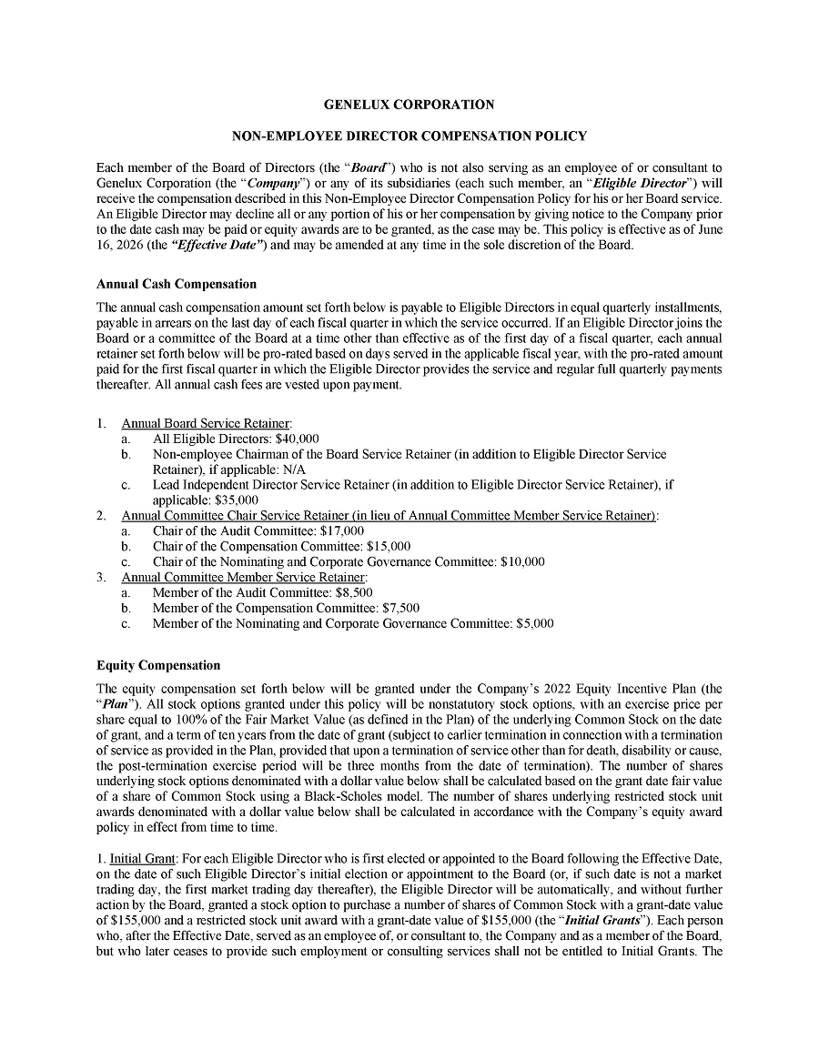

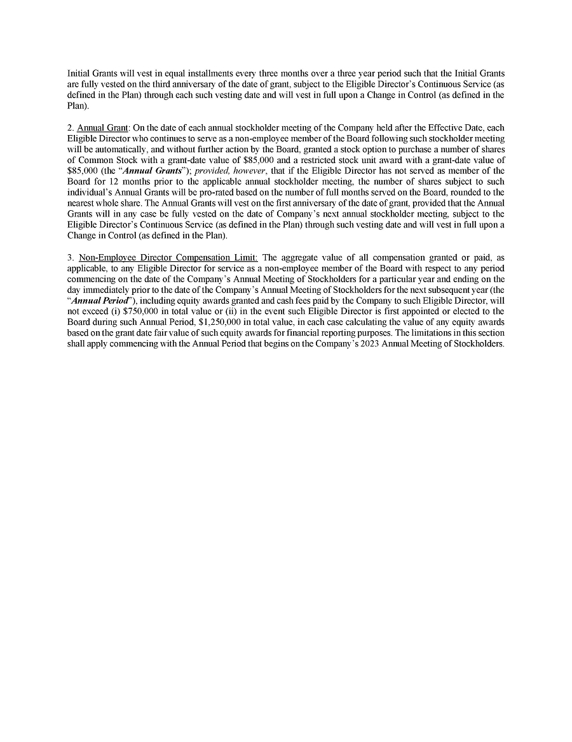

Exhibit 19

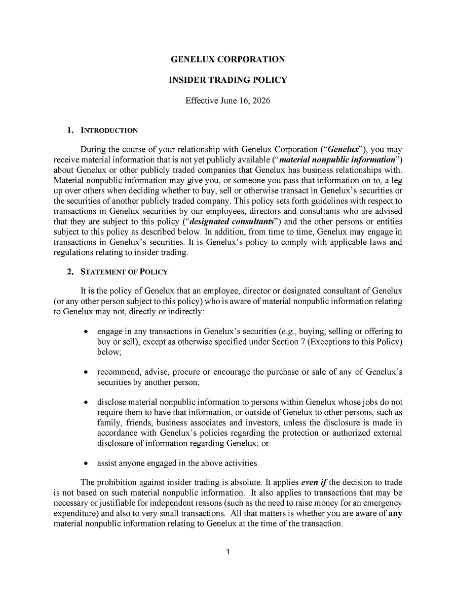

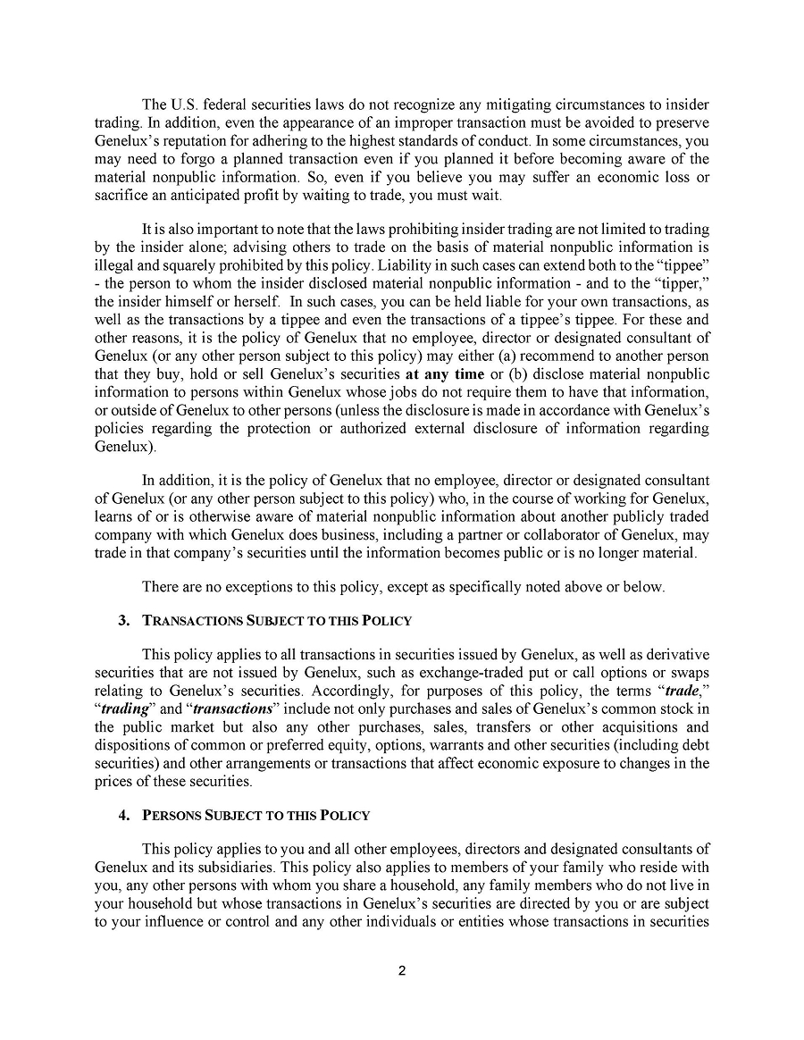

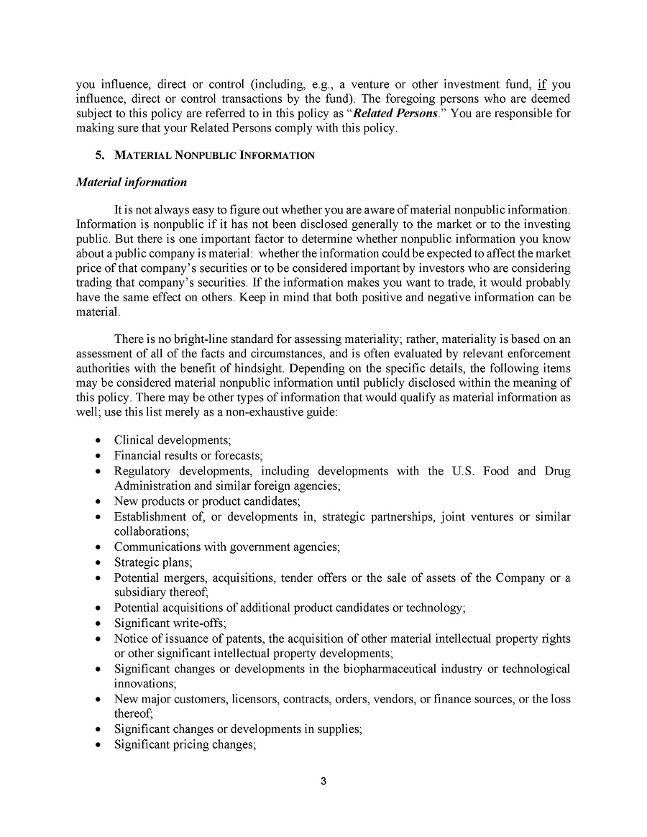

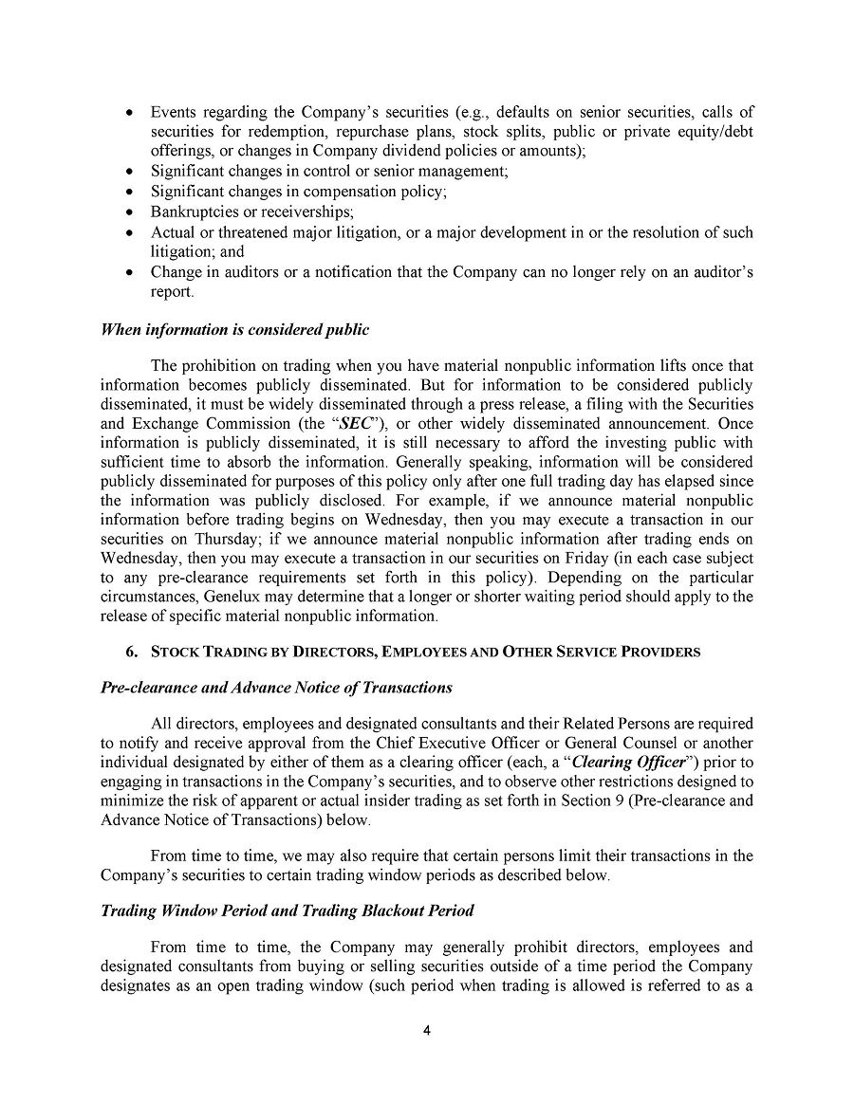

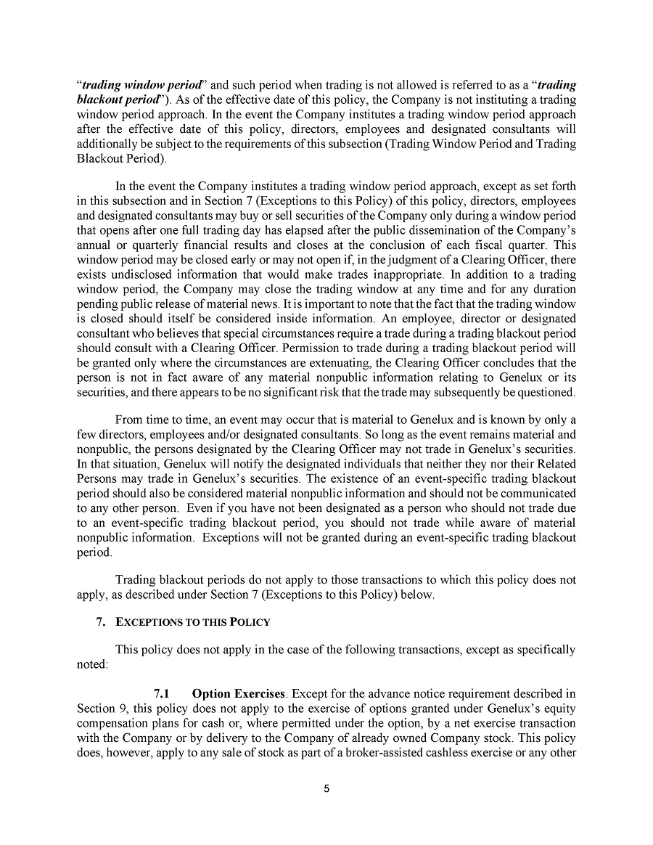

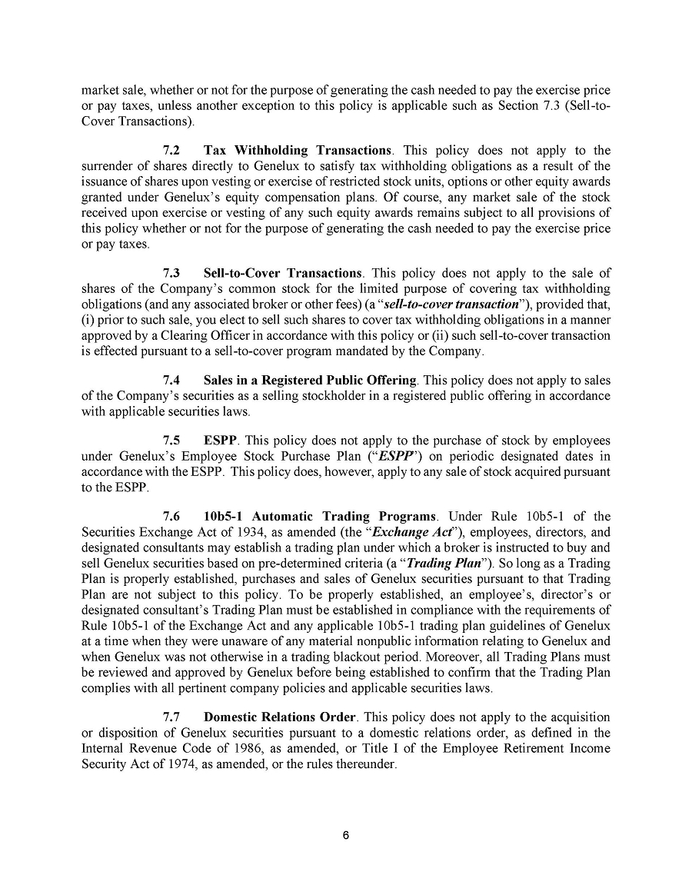

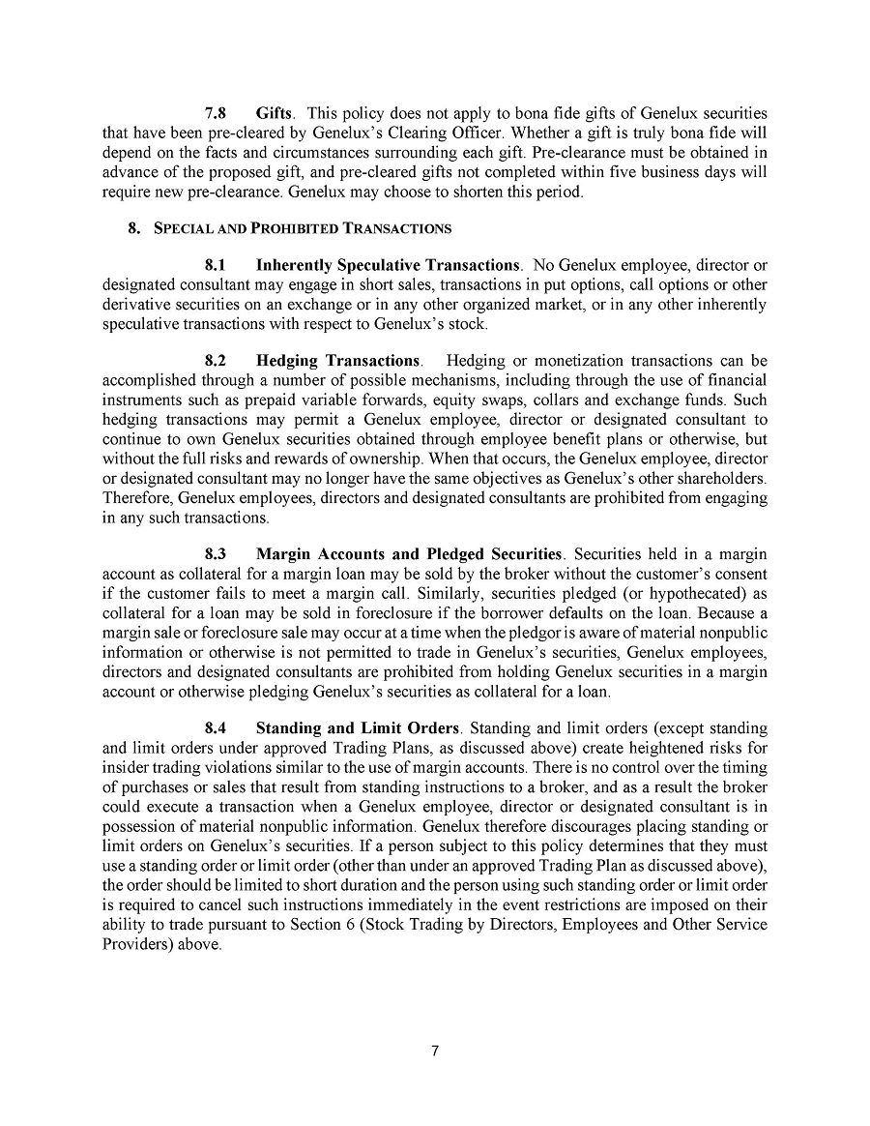

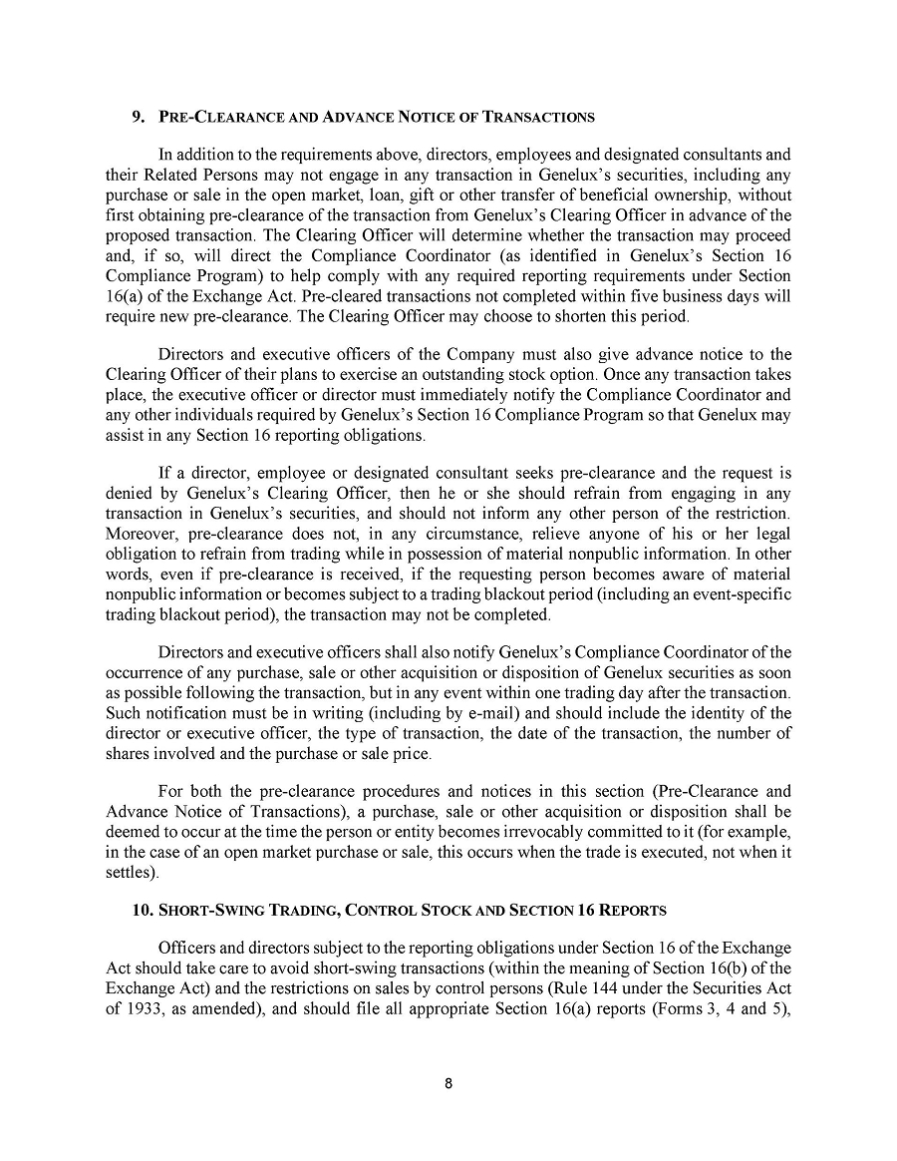

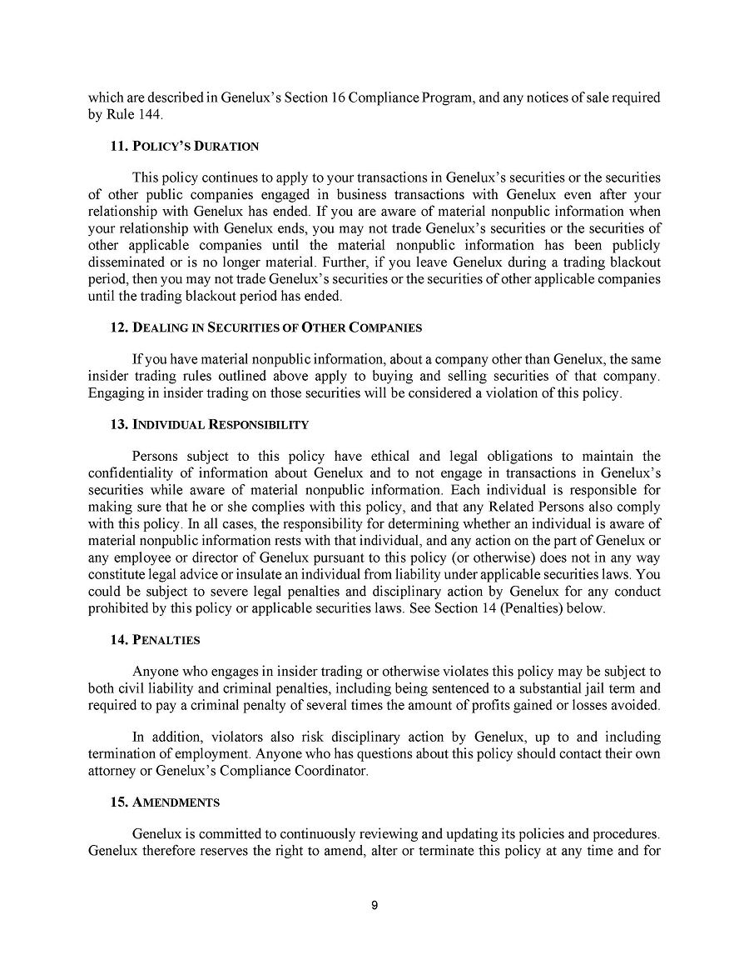



Exhibit 31.1

CERTIFICATION PURSUANT TO RULES 13a-14(a) AND 15d-14(a) UNDER THE SECURITIES EXCHANGE ACT OF 1934, AS ADOPTED PURSUANT TO SECTION 302 OF THE SARBANES-OXLEY ACT OF 2002

I, Thomas Zindrick, J.D., certify that:

1. I have reviewed this Quarterly Report on Form 10-Q of Genelux Corporation;

2. Based on my knowledge, this report does not contain any untrue statement of a material fact or omit to state a material fact necessary to make the statements made, in light of the circumstances under which such statements were made, not misleading with respect to the period covered by this report;

3. Based on my knowledge, the financial statements, and other financial information included in this report, fairly present in all material respects the financial condition, results of operations and cash flows of the registrant as of, and for, the periods presented in this report;

4. The registrant’s other certifying officer and I are responsible for establishing and maintaining disclosure controls and procedures (as defined in Exchange Act Rules 13a-15(e) and 15d-15(e)) and internal control over financial reporting (as defined in Exchange Act Rules 13a-15(f) and 15d-15(f)) for the registrant and have:

(a) Designed such disclosure controls and procedures, or caused such disclosure controls and procedures to be designed under our supervision, to ensure that material information relating to the registrant, including its consolidated subsidiaries, is made known to us by others within those entities, particularly during the period in which this report is being prepared;

(b) Designed such internal control over financial reporting, or caused such internal control over financial reporting to be designed under our supervision, to provide reasonable assurance regarding the reliability of financial reporting and the preparation of financial statements for external purposes in accordance with generally accepted accounting principles;

(c) Evaluated the effectiveness of the registrant’s disclosure controls and procedures and presented in this report our conclusions about the effectiveness of the disclosure controls and procedures, as of the end of the period covered by this report based on such evaluation; and

(d) Disclosed in this report any change in the registrant’s internal control over financial reporting that occurred during the registrant’s most recent fiscal quarter (the registrant’s fourth fiscal quarter in the case of an annual report) that has materially affected, or is reasonably likely to materially affect, the registrant’s internal control over financial reporting; and

5. The registrant’s other certifying officer and I have disclosed, based on our most recent evaluation of internal control over financial reporting, to the registrant’s auditors and the audit committee of the registrant’s board of directors (or persons performing the equivalent functions):

(a) All significant deficiencies and material weaknesses in the design or operation of internal control over financial reporting which are reasonably likely to adversely affect the registrant’s ability to record, process, summarize and report financial information; and

(b) Any fraud, whether or not material, that involves management or other employees who have a significant role in the registrant’s internal control over financial reporting.

Date: August 13, 2026

 | By: | /s/ Thomas Zindrick, J.D.
 |  | Thomas Zindrick, J.D.
 |  | President, Chief Executive Officer and Chairman
 |  | (Principal Executive Officer)

Exhibit 31.2

CERTIFICATION PURSUANT TO RULES 13a-14(a) AND 15d-14(a) UNDER THE SECURITIES EXCHANGE ACT OF 1934, AS ADOPTED PURSUANT TO SECTION 302 OF THE SARBANES-OXLEY ACT OF 2002

I, Matthew Pulisic, certify that:

1. I have reviewed this Quarterly Report on Form 10-Q of Genelux Corporation;

2. Based on my knowledge, this report does not contain any untrue statement of a material fact or omit to state a material fact necessary to make the statements made, in light of the circumstances under which such statements were made, not misleading with respect to the period covered by this report;

3. Based on my knowledge, the financial statements, and other financial information included in this report, fairly present in all material respects the financial condition, results of operations and cash flows of the registrant as of, and for, the periods presented in this report;

4. The registrant’s other certifying officer and I are responsible for establishing and maintaining disclosure controls and procedures (as defined in Exchange Act Rules 13a-15(e) and 15d-15(e)) and internal control over financial reporting (as defined in Exchange Act Rules 13a-15(f) and 15d-15(f) for the registrant and have:

(a) Designed such disclosure controls and procedures, or caused such disclosure controls and procedures to be designed under our supervision, to ensure that material information relating to the registrant, including its consolidated subsidiaries, is made known to us by others within those entities, particularly during the period in which this report is being prepared;

(b) Designed such internal control over financial reporting, or caused such internal control over financial reporting to be designed under our supervision, to provide reasonable assurance regarding the reliability of financial reporting and the preparation of financial statements for external purposes in accordance with generally accepted accounting principles;

(c) Evaluated the effectiveness of the registrant’s disclosure controls and procedures and presented in this report our conclusions about the effectiveness of the disclosure controls and procedures, as of the end of the period covered by this report based on such evaluation; and

(d) Disclosed in this report any change in the registrant’s internal control over financial reporting that occurred during the registrant’s most recent fiscal quarter (the registrant’s fourth fiscal quarter in the case of an annual report) that has materially affected, or is reasonably likely to materially affect, the registrant’s internal control over financial reporting; and

5. The registrant’s other certifying officer and I have disclosed, based on our most recent evaluation of internal control over financial reporting, to the registrant’s auditors and the audit committee of the registrant’s board of directors (or persons performing the equivalent functions):

(a) All significant deficiencies and material weaknesses in the design or operation of internal control over financial reporting which are reasonably likely to adversely affect the registrant’s ability to record, process, summarize and report financial information; and

(b) Any fraud, whether or not material, that involves management or other employees who have a significant role in the registrant’s internal control over financial reporting.

Date: August 13, 2026

 | By: | /s/ Matthew Pulisic
 |  | Matthew Pulisic
 |  | Chief Financial Officer
 |  | (Principal Financial and Accounting Officer)

Exhibit 32.1

CERTIFICATION PURSUANT TO 18 U.S.C. SECTION 1350,
AS ADOPTED PURSUANT TO SECTION 906 OF THE SARBANES-OXLEY ACT OF 2002

Pursuant to the requirement set forth in Rule 13a-14(b) of the Securities Exchange Act of 1934, as amended, (the “Exchange Act”) and Section 1350 of Chapter 63 of Title 18 of the United States Code (18 U.S.C. §1350), Thomas Zindrick, J.D., President and Chief Executive Officer of Genelux Corporation (the “Company”), and Matthew Pulisic, Chief Financial Officer of the Company, each hereby certifies that, to the best of his or her knowledge:

(1) The Company’s Quarterly Report on Form 10-Q for the period ended June 30, 2026, to which this Certification is attached as Exhibit 32.1 (the “Report”), fully complies with the requirements of Section 13(a) or Section 15(d) of the Exchange Act; and

(2) the information contained in the Report fairly presents, in all material respects, the financial condition and results of operations of the Company.

Date: August 13, 2026

/s/ Thomas Zindrick, J.D. |  | /s/ Matthew Pulisic
Thomas Zindrick, J.D. |  | Matthew Pulisic
President, Chief Executive Officer and Chairman |  | Chief Financial Officer
(Principal Executive Officer) |  | (Principal Financial and Accounting Officer)

This certification accompanies the Form 10-Q to which it relates, is not deemed filed with the Securities and Exchange Commission and is not to be incorporated by reference into any filing of Genelux Corporation under the Securities Act of 1933, as amended, or the Securities Exchange Act of 1934, as amended (whether made before or after the date of the Form 10-Q), irrespective of any general incorporation language contained in such filing.

